Foundation Practice Rating 2022
Assessing diversity, accountability and transparency in grant-making foundations
Friends Provident Foundation

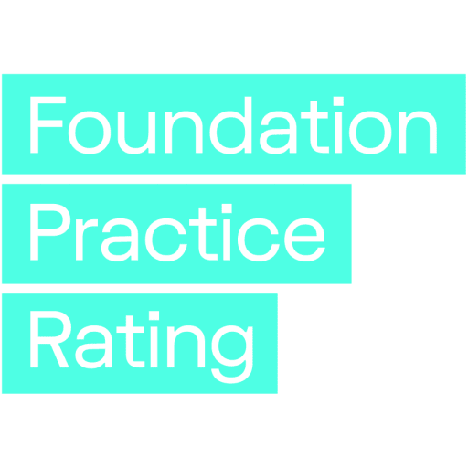

Further information
This report can be downloaded free of charge from the Foundation Practice Rating website.
Twitter: Foundation Practice Rating

Published 2022 by
Friends Provident Foundation
Blake House
18 Blake Street
York YO1 8QG
© Friends Provident Foundation 2022
Friends Provident Foundation
Friends Provident Foundation is an independent charity that makes grants and uses its endowment towards a fair and sustainable economic system that serves people and planet. We connect, fund, support and invest in new thinking to shape a future economy that works for all. Since 2004, we’ve pioneered the creation of fair economy for a better world. Already, we’ve helped improve access to financial services for people who were once excluded, and supported the development of resilient economic communities across the UK.
We’re a catalyst for wider change, making an impact through continuous experimentation and shared learning. And we do all we can to embody the change we want to see. We invest in great social enterprises, and use our money in line with our values. Tomorrow, we’ll continue to fund more new thinking, connect new ideas, invest our capital in line with our aims and values and create better systems so that in the future the economy will serve both people and planet.
Website: Friends Provident Foundation
Registered charity number 1087053
Twitter: Friends Provident Foundation
LinkedIn: Friends Provident Foundation
Facebook: Friends Provident Foundation

Contents
Acknowledgements v
Executive summary 1
01. Background to the project 4
The genesis of this project 5
02. How the Foundation Practice Rating works 6
Scope: Which foundations were included? 6
Who did what? 7
Funding 7
Research 8
Decisions 8
A rating, not a ranking or index 8
Two key principles 9
Objectivity 9
Taking the stance of a prospective applicant 9
How the criteria were defined 10
The three pillars of diversity, accountability and transparency 10
Defining the criteria 10
The diversity pillar also includes accessibility 12
The inter-relatedness of the three pillars 13
The research process 13
Public information only 13
The data-gathering process 13
Amendments to questions 13
Converting data into scores for each pillar 14
Exempting foundations from some criteria 14
Calculating the pillar scores 14
Converting pillar scores into an overall rating for each foundation 15
03. Results 17
The distribution of overall scores, and scores by pillar 17
Poor practice on diversity 19
The ratings for each foundation 20
The ratings of the foundations funding this project, and of community foundations 24
The distribution of overall scores in each pillar 25
Does size matter? 27
Financial size 27
Team size 29
Low scores aren’t confined to small foundations 30
Criteria on which foundations scored highest 31
Criteria on which foundations scored lowest 32
Do as I say, not as I do 33
Examples of great practice 33
Other findings by pillar 35
04. Reactions from foundations 37
Helpful pointers for improvement 37
A tool for self-assessment 38
Not a grant-making foundation 38
A prompt to amend priorities 38
05. Next steps 39
Next year’s research and analysis 39
Assessing the impact of this rating project 39
Appendices 41
A. Background on ratings systems from which some criteria were drawn 41
The Racial Equality Index 41
Give.org’s BBB Wise Giving Alliance: Standards for Charity Accountability 41
Funders Collaborative Hub: DEI Data Standard 41
Social Mobility Foundation: Social Mobility Employer Index 42
Candid: GlassPockets Transparency Standard 42
B. Example of foundations that exhibit each item assessed 43
C. Detailed criteria in the FPR 47
D. Eliminated criteria 60
E. Exemption rules 62
Diversity exemptions 62
Accountability exemptions 63
Transparency exemptions 63
F. Correlations between number of staff and number of trustees, and scores 65
G. Ratings of foundations funding this project, of community foundations, and foundations with each overall rating 66
Foundations that scored B or better overall (listed alphabetically) 67
Foundations that scored C overall (listed alphabetically) 68
Foundations that scored D overall (listed alphabetically) 69

Acknowledgements
This project was born of a belief that trusts and foundations in the UK have a vital role to play in addressing the many challenges facing us today, including existential risks from climate change, inequality and communities growing ever more distant from power. It was also grounded in a concern that foundations as organisations were not fit for responding effectively to those challenges because we have few incentives to engage with the many sources of advice and good practice that surround us.
A conversation with charity journalist David Ainsworth was the spark that led to the creation of the Foundation Practice Rating with its focus on improving foundation diversity, accountability and transparency.
Thank you to the charity leaders that agreed to engage with and fund this experiment from the start – Sara Llewellin, Debbie Pippard, Moira Sinclair, Kirsty Gillan-Thomas, Jo Wells, Caroline Mason, Josh Cockcroft, Vidhya Alakeson, Celia McKeon, Michael Pitchford, Julian Corner, Fiona Weir, Sufina Ahmad and Nicola Pollock.
We also thank all those who gave their enthusiasm and expertise to the shaping of the criteria and approach including Fozia Irfan, Uma Mishra, Max Rutherford, Ben Cairns, Jake Furby and Helen Adcock.
We would like to acknowledge the huge contribution to the development of this initiative by Caroline Fiennes, Director of philanathropy consultancy Giving Evidence. She assembled an excellent team under her direction, including the author of Modern Grantmaking, Gemma Bull, and Dr Sylvia McLain, who led the research team. We thank the researchers Dinah McKenzie, Sorayya Khan, Michele McGinnis, Reshmi Sarkar, Akosua Koranteng and Usama Kayani for their diligence and care in producing a robust piece of analysis.
Thanks too to Tania Mason of Civil Society Media, Alison Elks of Magenta Publishing, Jay Bigford of Yoke design and Nettl of York for their expertise in producing clear and readable articles, reports, branding and web resources for this project – you made it all look easy.
And finally, thanks to the Trustees of Friends Provident Foundation for their patience, unfailing support and for letting me follow my passion for this work as the project took shape over several years.
Danielle Walker Palmour
Friends Provident Foundaiton

Executive summary
“The future is already here – it’s just not evenly distributed.” (William Gibson)
The Foundation Practice Rating (FPR) is an objective third-party assessment of UK-based charitable grant-making foundations in three key areas of practice – diversity, accountability, and transparency. The FPR is a new rating that will be published annually with the aim of creating an incentive for foundations to improve their practices in these three areas.
This report describes how the FPR works and why, the findings from its first year of operation, and the response so far from foundations. It reveals the situation as it exists today, but it is hoped that it will also encourage future change that will lead to a stronger and more effective foundation and charity sector.
This groundbreaking project was originated by Friends Provident Foundation. The assessment was carried out by Giving Evidence using publicly available information, and the foundations assessed had no influence over the findings. Each foundation was assigned a rating of A, B, C or D on each of the three ‘pillars’ of diversity, accountability and transparency, and was then given an overall rating.
The research team assessed 100 UK-based charitable grant-making foundations. The sample included: the ten foundations funding this work (see page 7); the five largest UK foundations by giving budget; and a sample of charitable and community foundations. The practice of each foundation was rated on around 90 relevant criteria. These were drawn from and inspired by existing ratings and indices from the voluntary and other sectors, and informed by an open public consultation. Existing thresholds and definitions were used wherever possible. The criteria, and guidance on how the criteria would be assessed, were published before the assessments were carried out. Following the assessment and rating, all the included foundations were sent their data to check. Figure 8 (page 20) shows the scores for each of the foundations included in the Foundation Practice Rating in this first year.
The FPR revealed two major findings:
- Performance in these three areas was not particularly related to foundations’ size or structure.
- Practice on diversity is much weaker than that on accountability and transparency.
In relation to size, the 100 foundations were classified into quintiles by giving budget and net assets. The three ‘top-scoring’ foundations (the only ones with an overall score of ‘A’) were spread across these quintiles: Europe’s largest endowed foundation (Wellcome Trust); a community foundation in the third quintile by giving budget (County Durham Community Foundation); and an endowed trust in the fourth quintile (The Blagrave Trust).
When the foundations were ranked by giving budget, each quintile contained foundations scoring B, C and D. The same happened if the foundations were grouped according to their net assets. This suggests that organisations don’t have to be large or rich to achieve high levels of perfomance.
Neither do foundations need lots of people. All three of the top-scoring foundations had between six and ten trustees. Two had only ten staff each; the third, at the other end of the spectrum, had nearly 2,000 staff.
However, foundations with no staff tended to score badly (despite being exempted from criteria that they can’t be expected to meet, such as publishing their pay gap data): nearly two-thirds scored D overall, and over a quarter scored C. Similarly, foundations with five or fewer trustees also tended to score badly: over half scored D overall and a further quarter scored C. In this sample, there is a weak correlation between having more trustees and higher scores.
In relation to the second major finding, that practice on diversity is much weaker than that on accountability and transparency, whereas 18 foundations scored A on accountability and 54 scored A on transparency, no foundation scored A on diversity. The average numerical score on diversity was also much lower, and 16 foundations scored no points at all on diversity. In fact, so few foundations published a breakdown of their staff or trustees by gender, ethnicity or disability that this data could not be used.
Despite some very good practice on transparency, there were still challenges. For a start, 27 of the 100 foundations had no website. Only around a third published any analysis relating to effectiveness – even though most of these foundations asked this of organisations that they funded. It is possible that this is due to a lack of curiosity amongst foundations about what they are achieving and how to improve, a lack of understanding of how to go about assessing their own effectiveness, and/or a lack of willingness to be open about their achievements.
Community foundations and the foundations that funded this project scored better than average: two (one of each type) scored A overall, and the rest scored B overall.
Collectively, the criteria on which the 100 assessed foundations scored best were:
- publishing an investment policy and the details of it (note that this a legal requirement for some foundations, but not all);
- having a website;
- stating who their staff were;
- publishing information about their funding priorities and previous/existing grantees.
They collectively scored worst on:
- publishing a breakdown of the diversity of trustees/board members, and having a plan to increase that;
- publishing a breakdown of the diversity of staff, and having a plan to increase that;
- publishing in Welsh;
- providing contact mechanisms for disabled people – both for general purposes and specifically concerning malpractice.
In quite a few instances, foundations seemed to ask their grantees to do things that they themselves did not do. For example, some foundations required grantees to commit to paying the Living Wage but did not appear to have a public commitment to doing so themselves; and some required grantees to consult with the communities they served (e.g. to determine their priorities), but, again, did not appear to commit publicly to doing so themselves.
Foundation Practice Rating has the potential to guide and encourage foundations to improve their practice, to better use their scarce resources and serve society. The results from the first year of the rating system have been very encouraging. Foundations’ reactions have been remarkably positive; many have said that it highlights areas where they can improve and provides an impetus for them to act, and some have begun to use it themselves, as a tool for self-assessment.

01. Background to the project
In 2019, UK trusts and foundations had assets of over £62 billion, used to support charities, social enterprises, people in need and good causes through grants (and sometimes other financial instruments) that amounted to over £4.7 billion in 2018/19. Charities play an important part in national life, and the foundations that give to them are a crucial part of that. By taking a long-term view, they can respond to crises (as demonstrated during the Covid-19 pandemic) by increasing their giving even when their income falls, providing vital funding to important work.
Trusts and foundations highly value their independence from government. Many do not need to raise funds, and so don’t rely on any other party for anything. This enables them to operate with little transparency about what they do and how they do it. This can be a strength – it allows them to fund important but possibly unpopular causes, and can unlock charitable funding from people who wish to give but are not comfortable with publicity. Foundations’ independence allows them to stay true to their missions, and gives them the ability to ‘speak truth to power’, regardless of fashions or political interests.
But such independence can also be a weakness. The sector clearly lacks diversity. Recent research into trustees of foundations in England and Wales found that:
- 92 per cent are white
- Men outnumber women 2:1
- 60 per cent are over 65 years old
- Two-thirds are recruited informally
This matters because of social justice. In addition, plenty of research shows that less diverse groups make less good decisions than more diverse groups. Foundations often seek to support less advantaged people, and a lack of diversity within their teams could prevent them from finding, recognising or funding the best work and organisations to help them do this. Equally, if foundations’ materials and processes are not accessible to diverse groups, that will impede the foundation in supporting these groups. So the FPR looks at how foundation practices promote accessibility and diversity.
Because of the ability of foundations to do good, and because they are in effect supported by the taxpayer, we all have a stake in how well they do. However, foundations lack accountability to donors or the public, other than through charity law and their regulators. Beside regulators, most foundations are accountable only to their boards, which do not always reflect the population as a whole or the communities they serve.
Among other effects, this weak accountability reduces the potential for learning and improvement. Charities and nonprofits seeking or receiving funding may well be unwilling to tell a foundation how they really feel about its practices, even if things have gone wrong, or if there are important lessons a foundation might learn in order to improve. People can understandably worry that challenging feedback could be unwelcome and may impair their relationship with a foundation, reducing their chances of receiving funding, and even, therefore, threatening the viability of their own organisation.
Lack of transparency about what foundations do can leave charities in the dark about how foundations work – meaning that dealing with foundations can be unnecessarily costly, which wastes scarce resources. Only 218 UK funders publish their grant data in an accessible format through 360 Giving, and there are no common standards for reporting on grants, investment holdings or other activities, other than the regulatory standards. This has been addressed at various times, most recently by the Association of Charitable Foundations (ACF) as part of its Stronger Foundations initiative.
At the heart of these issues is power – independent funders tend to be relatively powerful in the relationships in which they operate. Organisations seeking funds are rarely able to question the source of funds, or the legitimacy of the funder. However, in the era of big data and increasing democratisation of information (think how easy it is now to find customers’ opinions of hotels or restaurants compared to 25 years ago), these traditional relationships are shifting. Foundations are beginning to recognise – as evidenced in the ACF’s Foundation Giving Trends 2019 report – that charities’ effectiveness and responsibility are based on increasing diversity and inclusivity, being accountable to the organisations that they seek to support and to society more widely, and increasing their transparency.

The genesis of this project
Ten UK foundations (see page 7) recognised these issues are important, and together wanted to support the trust and foundation sector to improve on them, encouraging and celebrating examples of good practice, and challenging current practices where necessary.
They commissioned Giving Evidence to develop and implement a system for rating UK foundations on these three issues of diversity, accountability and transparency. The result is the Foundation Practice Rating (FPR), which provides an objective third-party assessment of foundations. The FPR uses a technique often used to increase accountability amongst corporates – a published rating, created using publicly available information. It draws on other ratings and indices, such as the Social Mobility Employer Index.
This report describes how the FPR was developed and implemented, its first year of results, and how foundations have responded.

02. How the Foundation Practice Rating works

Scope: Which foundations were included?
The FPR assessed only charitable grant-making foundations. Public grant-making agencies (such as local authorities or the research councils) were not included because they have other accountability mechanisms.
There are hundreds of charitable foundations in the UK, so a sample of 100 were chosen. The sample comprised:
- The ten foundations funding this project. The aim of the project is not to criticise other foundations’ work, but instead to improve practice in the whole sector. All of the funding foundations have been assessed using the same criteria as the other foundations, as part of their own strategies for self-improvement. The foundations funding this project are listed in the next section.
- The five largest foundations in the UK (by grant budget). These foundations dominate UK grant-making overall, and therefore have a significant impact on the areas in which they give. The UK’s ten largest foundations give over a third of the total given by the UK’s largest 300 or so foundations.
- A stratified random subset of other foundations. The UK’s largest foundations (as published in the ACF’s Foundation Giving Trends 2019 report), and the community foundations listed by UK Community Foundations for whom financial information is given, added up to a total of 383 foundations. The researchers took a random sample of a fifth from the top quintile (in terms of annual giving budget), a fifth from the second quintile, and so on. This provided the other 85 foundations that were assessed using the FPR.
The 100 foundations in the sample collectively had:
- net assets of £44.4 billion;
- annual giving of £1.25 billion;
- an average pay-out rate (i.e. the amount given annually as a proportion of assets) of 3 per cent.
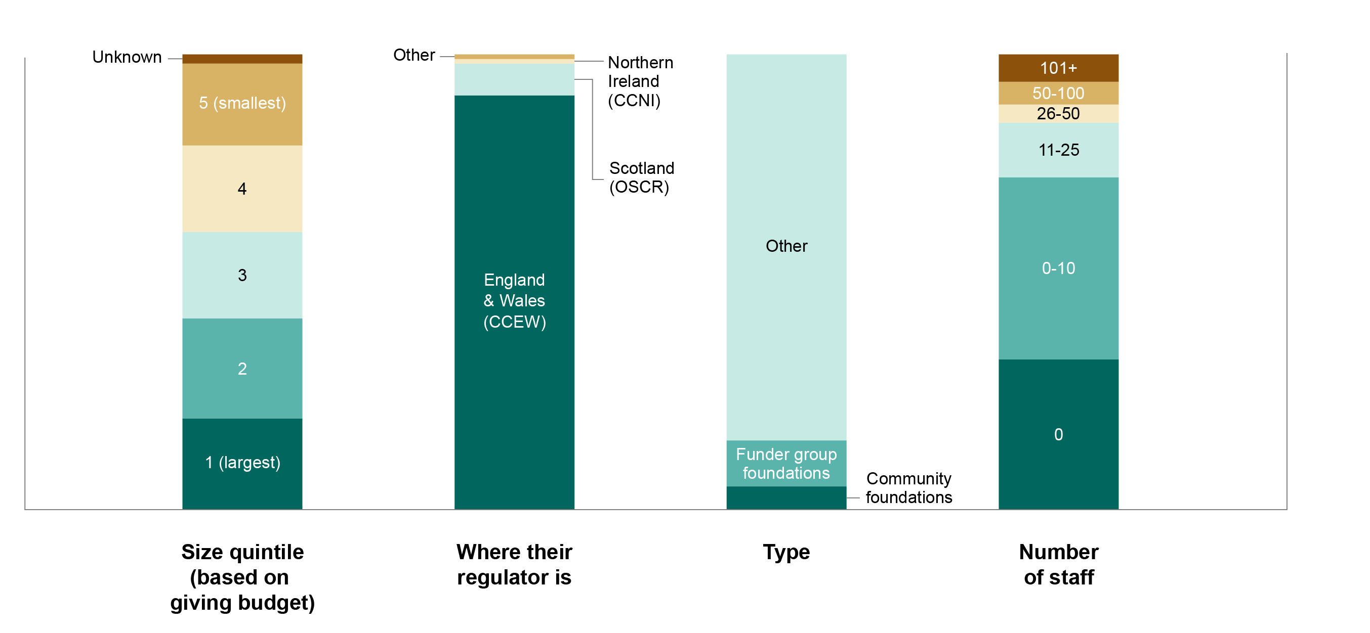
Figure 1: Composition of the sample
For future years, the foundations included in the FPR will be:
- again, the funding foundations;
- again, the five largest foundations;
- a fresh sample of other foundations drawn at random. This means that individual foundations rated this year may not be included next year (unless they are in the funder group or are one of the five largest). Equally, foundations who were not rated this year may be assessed next year.
This approach has both pros and cons. On the one hand, foundations included this year but not next will not get the continuity of repeated assessment. On the other hand, it means that all UK foundations know that they could be rated, which provides an incentive to improve; and the results should provide a more faithful picture of the progress of the sector as a whole, and not just the set of previously assessed foundations.

Who did what?

Funding
The project is funded by:
Friends Provident Foundation
Barrow Cadbury Trust
The Blagrave Trust
Esmée Fairbairn Foundation
John Ellerman Foundation
Joseph Rowntree Reform Trust
Joseph Rowntree Charitable Trust
Lankelly Chase Foundation
Paul Hamlyn Foundation
Power to Change
These foundations, collectively called ‘the Funders Group’, meet periodically to advise on the project. The Association of Charitable Foundations also joins these meetings.

Research
The design of the rating system (including defining the criteria and research process) was led by Giving Evidence, an independent consultancy and research house. Giving Evidence works to encourage and enable giving based on sound evidence. It developed the rating system, including the criteria and scoring system, and produced the research and analysis for the ratings.

Decisions
The Funders Group has no control over the detail of the assessment, nor the ratings assigned to individual foundations.

A rating, not a ranking or index
It is important to stress that the FPR provides a rating of foundations, not a ranking.
A rating is an absolute measure of performance. In a rating system, everybody can be in the ‘top drawer’, or everybody can be in the ‘bottom drawer’. This contrasts with a ranking, which shows relative performance (who is top, who is second, and so on).
The FPR is a rating because it is intended to assess what prospective applicants experience, which is absolute performance. If all the foundations they work with are brilliant, it doesn’t much matter which one is slightly more brilliant than the others; and if they are all awful, again, it doesn’t matter who is marginally the worst. Furthermore, ranking is a zero-sum system: if somebody rises, somebody else must fall – one organisation’s gain is at somebody else’s expense. This is not how foundation practice works.
A rating – by showing foundations’ performance on an absolute scale – gives a stronger signal for improvement than a ranking would, and is also capable of indicating the improvement of the sector overall.
Equally, the FPR is not intended as an index. An index – such as the Retail Price Index – is intended to track changes over time, rather than highlight their absolute level.

Two key principles

Objectivity
A key principle in developing the rating system was to be as objective as possible. The decisions were based on external sources whenever possible. For example:
- An existing list of foundations was used, rather than creating a new one.
- Other self-assessment tools and ratings in the private, public and non-profit sectors – such as GlassPockets’ Transparency Standard, Give.org’s BBB Standards for Charity Accountability, the Social Mobility Employer Index and the Racial Equality Index – were used to define the FPR criteria. There was also a public consultation about these criteria.
- The various criteria were all given equal weighting; no single criterion was deemed more important than another.
- Each pillar – diversity, accountability and transparency – was given equal weight in the overall score.
- On assessing foundations’ investment policies and whether they should have them, the FPR used the fact that GlassPockets features a criterion that foundations should include an investment policy, and the Charity Commission for England and Wales’ criteria on what investment policies should contain.
Nonetheless, some scores unavoidably involved subjective judgements. For instance, one criterion asked whether a foundation had published any analysis of its own effectiveness (distinct from listing grantees or the budgets of its various funding streams): the researchers had to judge whether any particular document constitutes analysis of that foundation’s effectiveness.

Taking the stance of a prospective applicant
Central stakeholders for a foundation are the groups that it seeks to serve. The research was therefore designed to mimic their experience by taking the stance of an individual looking to apply to the foundation for funding:
- Only publicly available data was used. The ratings were based on information from foundations’ websites and their annual reports and accounts filed with the regulator. These are the sources most likely to be used by a prospective applicant. Other materials, such as those presented at events, or on social media, were not taken into account
- A time limit was set for the research. Each researcher spent up to 90 minutes researching each foundation, a plausible amount of time that an individual might spend on initially researching a possible funder. Sometimes the information was hard to find: sometimes it took 90 minutes to find it all, at other times it took less time. A prospective applicant may not take (or have) that much time. In other words, even if the information was found and the foundation scored well on that aspect, there may well still be scope to make information easier to find.

How the criteria were defined

The three pillars of diversity, accountability and transparency
The FPR covers three ‘pillars’:
- Diversity. To what extent does a foundation report on the diversity of its staff and trustees and its plans to improve its diversity, and how well does it cater for people who prefer/need to communicate in different ways? The FPR did not look at issues such as how well foundations captured views from a diverse set of stakeholders to inform their work, nor what or whom foundations fund.
- Accountability. How can anyone who wants to examine the work or decisions of a foundation after the event do so, and make their voice heard?
- Transparency. Does a potential grantee have access to the information that they need to be able to contact the foundation in order to decide whether to apply for funding, or make general enquiries?
The FPR did not examine what the foundations actually funded – at least, not in this first year. It is possible that a foundation with poor disclosure and undiverse staff might fund very diverse organisations and activities. This issue might be addressed in future years.
The FPR attempted to measure the diversity of staff and trustees, but the lack of data published by foundations about this made it impossible. Only four of the rated foundations published a staff diversity breakdown; none published a trustee diversity breakdown, other than the Rhodes Trust, which published its ethnic breakdown. This provided very limited data about the diversity of foundation staff and trustees, and hence it could not be analysed reliably.
Some foundations did not have websites and/or did not disclose particular information for good reason, because of how they operate. For instance, some foundations that fund human rights work might want to avoid attracting attention – particularly to their grantees – because that may imperil them.
The rating does not imply that some ways of doing philanthropy are better than others. But it may prompt reflection about foundations’ practices in general, and their openness and Accountability, and this may ‘spill over’ into their funding approaches.

Defining the criteria
Criteria were developed in each of these three pillars against which to assess performance. The criteria are listed in Appendix C (page 47), which also shows the pillar to which each one belongs.
The criteria were selected through a process running from 30 March to 8 August 2021 that involved: initial discussions with the Funders Group; researching criteria used in other rating and ranking projects (UK and international); testing a subset of these criteria through a public consultation; soliciting suggestions from the general public via the Friends Provident Foundation website, Giving Evidence’s website and wider social media; interviews with sector and rating experts; and several rounds of feasibility testing. The final criteria were selected only if they met both of the following requirements:
- In scope. The criteria must relate to diversity, accountability and transparency. Any that did not were out of scope. For example, criteria only about environmental sustainability or relating to an assessment of a foundation’s impact or its strategy were out of scope.
- Observable and measurable. The rating process used only publicly available sources, and therefore the criteria had to relate to data that could be in the public domain. The evidence on whether a foundation met a criterion had to be measurable from the outside, and not require (for instance) interviews with staff or insider knowledge.
A public consultation on the criteria was carried out from 20 May to 9 June 2021. The public were invited to provide feedback on whether the proposed criteria should be included and to suggest any alternatives or amendments. A total of 138 responses were received.
Based on very positive participant feedback, all of the proposed criteria relating to transparency and accountability, and most criteria relating to diversity, were used to assess the foundations. Some new criteria were also incorporated from the suggestions, including, for example, to rate foundations on their accessibility.
In terms of external rating or ranking benchmarks, some of the criteria are based on similar criteria used in GlassPockets, BBB Wise Giving Alliance, Standards for Charity Accountability, the Racial Equality Index, the Social Mobility Employer Index, and a range of reports produced by the Association of Charitable Foundations as part of its Stronger Foundations initiative.
Figure 2 shows two examples of the final criteria, related external benchmarks and comments from the public consultation.
Figure 2: Sources of example criteria
Pillar | Criteria | Used in other ratings or rankings tools/guidance? | Public feedback
Transparency | Does the foundation publish on its website any information about its funding priorities? | GlassPockets; ACF Transparency and Engagement | 95% of consultation respondents strongly agreed that this criterion should be included.
Transparency | Does the foundation publish any eligibility criteria for what it funds? (i.e. who as a potential recipient would be eligible for a particular grant?) | GlassPocket; ACF Transparency and Engagement | 95% of consultation respondents strongly agreed that this criterion should be included.
The final criteria were then published and highlighted on social media to give foundations the option to start making improvements if they wished. Advice was published on the FPR and Giving Evidence websites on how foundations could achieve a high rating, as ‘Guidance on how to do well’.
Each of the 100 included foundations were scored on the criteria, giving well over 9,000 data-points (some criteria involve multiple data-points). Each foundation was given a rating on each pillar. The pillar scores were then converted into an overall rating for that foundation. This is described in more detail on pages 14–15.

The diversity pillar also includes accessibility
One of the strongest findings from the public consultation was that the FPR should include criteria about how accessible foundations are. Therefore, various criteria related to accessibility are included in the ‘diversity’ pillar, because they are about enabling a diverse audience to engage with the foundation.
A foundation’s accessibility was measured in several ways, including:
- How accessible its website was. An accessible website should meet the international Web Content Accessibility Guidelines (WCAG) that are recommended by the UK Government. The WCAGs include things like: make sure your website is accessible to people who can only use a keyboard, ensure that it is compatible with a screen reader and that web content is still legible in a single column when enlarged to 400 per cent, so that it can be used by people with visual impairments.
- Whether it provided different ways for people to get in touch. According to UK Government advice, the best way to make your information accessible to everyone is to ‘make effective use of accessible communication formats’. This includes having alternative formats for people with visual impairments, such as audio descriptions, a Braille option, or, for those that have hearing impairments, using technology such as text relay, or making British Sign Language or a telephone contact option available.
- Whether it provided eligibility information. Some foundations provide this kind of information solely via PDFs. However, PDFs cannot always be used easily by screen readers. Alternatives include an interactive eligibility quiz, a video explaining who is eligible and who is not, or an in-person roadshow for potential applicants and others. In short, the more formats that a foundation offers, the more audiences it can engage with and the more accessible it will be.
- Whether it provided different ways for people to apply. Similar to above, a foundation was assessed on whether it offered alternative ways in which people could apply for funding, such as offline or online application forms, in-person/virtual meetings, video application, etc.
It is possible that some foundations have a range of methods for people to get in touch or to apply for funding but that these were not publicly advertised. In such cases, the foundations were not given credit for that range, because a prospective applicant may not realise that they are there.

The inter-relatedness of the three pillars
There are close relationships between the three pillars. Therefore, a particular criterion may relate to two or even three pillars. For example, if a foundation publishes information on the diversity of its staff, that is about diversity (encouraging diverse applicants) and transparency (who it employs). A commitment to a Living Wage could be accountability, transparency (about its practices/ policies) or diversity (encouraging applicants and staff). Therefore, the most reasonable pillar for each criterion was chosen.

The research process

Public information only
As has been said, foundations were assessed from the viewpoint of a prospective applicant and therefore only publicly available data was used. Websites and annual reports are the main sources that a prospective applicant would use, so these were the only sources of information used for the rating.
This may not completely capture what foundations were doing; for example, if they were doing an excellent job involving a diverse group of stakeholders, but did not talk about that on their website or in their annual report, the rating gave no credit for that.

The data-gathering process
To increase accuracy and objectivity, each foundation was assessed independently by two researchers. Each researcher noted their answer for each foundation on the criteria. Their outputs were then compared and any discrepancy was resolved by the two researchers and the research manager.
After each foundation had been researched, the information about each was sent to that foundation so that it could check it, suggest corrections and point out any omissions. The foundation’s published preferred contact method was used: that was mostly email, but for some foundations the material was posted in hard copy. Three webinars were held in December 2021 for the included foundations, to discuss the project and answer foundations’ questions.
Several foundations pointed out information in other places, such as on LinkedIn. Some sent material as attachments that wasn’t publicly available. That data was not included in the FPR because it uses only information in the two places listed above. However, when foundations cited relevant information that was in their annual report or on their website that had been overlooked, scores were amended accordingly.

Amendments to questions
Some criteria proved to be impractical, or tended to duplicate. Examples of these were ‘Does the foundation publish its pay policy (such as tax, sickness, holiday entitlement, maternity, paternity, or shared parental leave or other)?’ and ‘Does the foundation state a policy of publishing salaries for any job advertisement (or is this clear in any current job announcement)?’ These two questions were eliminated because they could not be applied equally across all foundations – as the information was only available for those that had live job advertisements. A full list of the questions that were eliminated, and the reason why, is in Appendix D (page 60).
The data was gathered during September to December 2021, and sent to the foundations in late November/early December for them to check.

Converting data into scores for each pillar
In order to be as objective as possible, equal weight was given to all criteria – each was allocated one point.

Exempting foundations from some criteria
Not all questions were relevant to every foundation. For example, a foundation that only funds by invitation does not need to publish its eligibility criteria. When a criterion was not relevant to a foundation, it was not scored on that criterion. Another example is that many foundations have few (or no) staff: clearly, such foundations cannot be expected to publish gender pay gap data, and so they were exempt from that criterion.
A full list of the FPR’s exemption rules is in Appendix E (page 62).
One result of allowing these exemptions is that the maximum score available within a pillar varied between foundations: a foundation’s maximum possible score in a particular pillar was identified by including only the questions relevant to that foundation. For instance, foundations with fewer than 50 staff were exempted from the criterion about reporting pay gap data, and evidence of a staff diversity plan was exempted for foundations with ten or fewer staff.

Calculating the pillar scores
To obtain a foundation’s final score for each pillar, its actual score for that pillar was divided by the maximum possible score for it on that pillar, which gave a percentage figure.
Each foundation’s score was then converted into a grade. There are four grades, from A (the highest) to D. Four grades were chosen partly because various UK public sector rating/quality assessment systems have four (e.g. Ofsted, HM Inspectorate of Prisons, the Care Quality Commission). A to D were chosen because they are easy to understand.
Each foundation’s grade on each pillar has been published, but not the numerical scores. This is to prevent a ranking being constructed from the data, which would be unhelpful, for the reasons given earlier.

Converting pillar scores into an overall rating for
each foundation
Because of the rating’s overarching principle of being as objective as possible, the three pillars were weighted equally. A natural way to generate a foundation’s overall rating would simply be to take an average of its scores of the three pillars. However, really excellent performance requires a certain level of achievement in all three areas, rather than just an outstanding score in one or two. Some adjustments were therefore needed.
This issue was also addressed by the public sector comparators that were used. For example, in Ofsted’s ratings, if a school is rated as ‘inadequate’ on any of the four ‘buckets’ of criteria, it will be ‘inadequate’ overall: in other words, a school’s overall rating will not be higher than its lowest pillar score. The Care Quality Commission regulates health and social care provision in England. It assesses providers on various aspects, and if a provider scores below ‘good’ on any aspect, it cannot get an ‘outstanding’ rating overall.
The FPR uses the same principle. If a foundation scores badly on any pillar, it cannot be said to be excellent and to warrant a high rating overall. For instance, if a foundation scores A in the pillars of accountability and transparency, but scores D in diversity, this does not warrant an overall score of A.
So a foundation’s overall rating on the FPR can be, at most, one slot higher than its lowest pillar score. That is, if a foundation scores D in any pillar, the best overall score it can get is C. Similarly, if a foundation scores C in any pillar, the best overall score it can have is B. The overall rating of a foundation is determined by taking the lower of:
- what the overall grade would be if the foundation’s average score from the three pillars were converted into one number, and then into a grade;
- the lowest grade that a foundation achieved for an individual issue, increased by one.
This is illustrated in Figure 3.

Figure 3: Illustration of how overall ratings relate to ratings on individual pillars
Foundation | Diversity score | Accountability score | Transparency score | Rating based on the numerical average of its pillar scores | Actual overall rating | Reason
1 | A | B | A | A | A | Lowest score (B) raised by one is the same as simple average.
2 | A | C | A | A | B | Lowest score (C) raised by one is B, which is lower than average score.
3 | B | B | B | B | B | Simple average is B, and there is no reason to lower it.
4 | D | A | A | B | C | The lowest score (D) raised by one is C which is lower than the simple average (B). This foundation’s score is affected by its poor performance on diversity.
In fact, there were only a handful of foundations whose overall scores were different under the system described above than if a simple average had been used. They were mostly pulled down by their scores on diversity. Of the 100 foundations assessed, two moved from A to B by receiving C scores on diversity, and three moved from B to C – two for their scores on diversity and one for its score on accountability.
Because the assessment used only publicly available information, if a foundation had no website, or published only very scant information on its website, it could not score highly.
More details on the set of questions that were applied, scores and the calculation of scores, are in the appendices.

03. Results

The distribution of overall scores, and scores by pillar
The following graphs show a breakdown of the scores for the assessed foundations. Figure 4 shows the distribution of As to Ds in the overall scores and in each pillar.
Figure 4: Number of foundations achieving each rating – both overall, and within each pillar. n=100
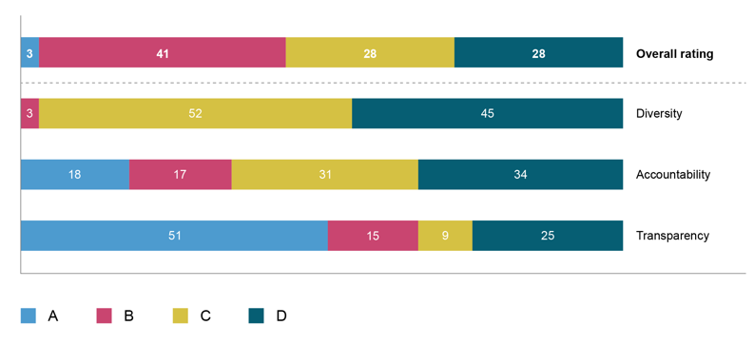
Only three foundations achieved an overall rating of A: the Wellcome Trust, the Blagrave Trust, and the County Durham Community Foundation. A first observation is how varied those three are: one is the largest foundation in Europe, with assets of £24 billion; one has assets of around £42 million; and one is a fundraising community foundation, which is around the middle of the sample by giving budget size. This suggests that good practice is not dependent on any one structure or size.
Figure 5 gives the breakdown of pillar scores within each of the overall scores as a percentage. It shows that most foundations are pretty consistent in their practice: few are very good at some things and very poor at others. Similiarly, those foundations that achieved A overall scored B on diveristy; and that those that scored D overall did marginally better on accountability and transparency than they did on diversity.
Figure 5: Breakdown of pillar scores of foundations with each overall score (percentage)
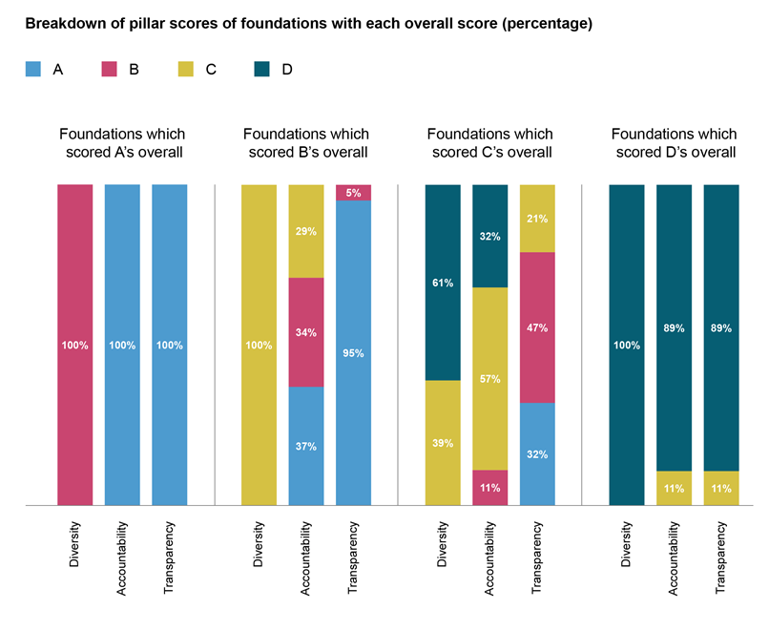

Are the criteria reasonable?
Every item that the criteria looked for (e.g. a diversity plan with numerical targets, a complaints policy, an analysis of its own performance) was found in at least one foundation, which demonstrates that all of them are attainable.
Appendix B (page 43) lists each criteria, and gives an example foundation that has each one. Readers looking for examples or guidance about creating these items can use that table.

Poor practice on diversity
A main finding is that practice on diversity is weaker than practice on the other pillars. No foundation scored A on diversity, whereas many were rated A on the other two pillars: 51 for transparency and 18 for accountability. This can also be seen by looking at the average scores across all 100 foundations on each pillar (Figure 6): the average grade for transparency is B, for accountability C, but for diversity it is D.
Only 14 foundations published a diversity plan for their staff (four of these foundations were exempted from this criterion in the final rating as they had fewer than 11 staff) and only 10 foundations had a diversity plan for their trustees. Only two of these diversity plans contained any targets: Wellcome Trust had targets for increasing the diversity of its staff; and Esmée Fairbairn Foundation had targets for increasing the diversity of its trustees.
Figure 6: Average scores on the pillars
Diversity | Accountability | Transparency
D  (near the border for C) | C | B
This pattern was also seen in the number of foundations scoring zero in each pillar:
Figure 7: Number of foundations scoring zero in each pillar
Diversity | Accountability | Transparency
16 | 0 | 4
Many foundations’ overall scores were lower on diversity than on the other two pillars. Thirteen scored CAA – C for diversity, and A for both accountability and transparency.
The particular criteria on which foundations scored well and poorly, including those on diversity, are discussed on pages 30–32.
It is of course possible that the criteria in some pillars are more difficult for a foundation to meet than those in other pillars. If so, that would account (in part or in full) for differences in the pillar ratings. It seems that there is no way of knowing this in absolute terms – though each item sought by the criteria is clearly possible because each item was found in at least one foundation.

The ratings for each foundation
Figure 8: Scores for all foundations included in the 2021 Foundation Practice Rating
Foundation | Diversity | Accountability | Transparency | Overall rating
Blagrave Trust | B | A | A | A
County Durham Community Foundation | B | A | A | A
Wellcome Trust | B | A | A | A
Albert Hunt Trust | C | B | A | B
Asda Foundation | C | C | A | B
Bank of Scotland Foundation | C | C | A | B
Baron Davenport’s Charity | C | C | A | B
Barrow Cadbury Trust | C | C | A | B
BBC Children in Need | C | A | A | B
Berkshire Community Foundation | C | B | A | B
Burdett Trust for Nursing | C | C | A | B
Children’s Investment Fund | C | A | A | B
Clergy Support Trust | C | A | A | B
Comic Relief | C | A | A | B
Cumbria Community Foundation | C | A | A | B
Drapers’ Charitable Fund | C | C | A | B
Dunhill Medical Trust | C | A | A | B
Esmeé Fairbairn Foundation | C | A | A | B
Foundation Derbyshire | C | B | A | B
Foyle Foundation | C | C | A | B
Friends Provident Foundation | C | B | A | B
The Edward Gostling Foundation | C | C | A | B
Greggs Foundation | C | B | A | B
Halifax Foundation (Northern Ireland) | C | B | A | B
Indigo Trust | C | B | A | B
John Ellerman Foundation | C | B | A | B
Joseph Rowntree Charitable Trust | C | B | A | B
Joseph Rowntree Reform Trust | C | C | A | B
KPMG Foundation | C | C | A | B
Lankelly Chase Foundation | C | A | A | B
LHR Airport Communities Trust | C | C | A | B
Lloyds Bank Foundation for England and Wales | C | A | A | B
London Marathon Charitable Trust | C | B | A | B
Northamptonshire Community Foundation | C | A | A | B
Nuffield Foundation | C | A | A | B
Paul Hamlyn Foundation | C | A | A | B
Performing Right Society Foundation | C | B | A | B
Power to Change | C | A | A | B
Rhodes Trust | C | A | B | B
Scottish Catholic International Aid Fund | C | B | B | B
The James Dyson Foundation | C | C | A | B
The Legal Education Foundation | C | A | A | B
The Mercers’ Charitable Foundation | C | B | A | B
The Ogden Trust | C | B | A | B
A M Qattan Foundation | C | C | B | C
Aga Khan Foundation (UK) | D | C | A | C
Asser Bishvil Foundation | D | D | B | C
Beit Trust | D | D | B | C
British Record Industry Trust | D | C | B | C
Christian Vision | C | C | B | C
Evan Cornish Foundation | C | C | A | C
Eveson Charitable Trust | D | B | A | C
Franciscan Missionaries of the Divine Motherhood Charity | D | D | B | C
Golden Bottle Trust | D | C | C | C
Hugh Fraser Foundation | C | D | C | C
Islamic Aid | D | D | C | C
Leverhulme Trust | D | C | A | C
Lloyd’s Register Foundation | D | C | A | C
Maitri Trust | D | D | B | C
Maurice and Vivienne Wohl Philanthropic Foundation | C | C | A | C
National Gardens Scheme Charitable Trust | D | C | A | C
Oxford Russia Fund | D | D | B | C
Resolution Trust | C | C | C | C
Rotary Foundation of the United Kingdom | C | C | C | C
Royal Navy and Royal Marines Charity | D | B | B | C
Steve Morgan Foundation | D | C | B | C
Swire Charitable Trust | C | D | A | C
The Becht Family Charitable Trust | C | C | B | C
The Charles Hayward Foundation | D | C | A | C
The Roddick Foundation | C | C | B | C
Volant Charitable Trust | D | D | B | C
Zurich Community Trust (UK) Ltd | C | B | C | C
29th May 1961 Charitable Trust | D | D | D | D
4 Charity Foundation | D | D | D | D
Backstage Trust | D | D | D | D
Barnabas Fund | D | D | C | D
Bernard Lewis Family Trust | D | D | D | D
Cadogan Charity | D | D | D | D
Chalfords Ltd | D | C | D | D
Charitworth Ltd | D | D | D | D
Charles Dunstone Charitable Trust | D | D | D | D
Chevras Mo’oz Ladol | D | D | D | D
Dunard Fund | D | D | D | D
EBM Charitable Trust | D | D | C | D
Gilmoor Benevolent Trust | D | D | D | D
Goodman Foundation | D | D | D | D
Hadley Trust | D | D | D | D
Hurdale Charity Ltd | D | D | D | D
JMCMRJ Sorrell Foundation | D | D | D | D
M & R Gross Charities Ltd | D | D | D | D
Rachel Charitable Trust | D | D | D | D
The Charles Wolfson Charitable Trust | D | C | D | D
The Desmond Foundation | D | D | D | D
The Dr Mortimer and Theresa Sackler Foundation | D | D | D | D
The Goldman Sachs Charitable Gift Fund (UK) | D | D | D | D
The Michael Bishop Foundation | D | D | C | D
The Northwood Charitable Trust | D | D | D | D
The Raphael Freshwater Memorial Association Ltd | D | C | D | D
Yesamach Levav | D | D | D | D
Zochonis Charitable Trust | D | D | D | D

The ratings of the foundations funding this project, and of community foundations
All the Funders Group foundations and community foundations scored slightly better than average: they all scored either A or B overall. The Blagrave Trust (which is a funder of this project) and the County Durham Community Foundation were among the only three foundations that scored A overall, scoring better than average on all three pillars.
On diversity, the Funders Group and the community foundations scored B or C. The average diversity score for all included foundations was on the D/C borderline.
On accountability, all of the community foundations scored either A or B, as did most of the Funders Group, with the exception of Barrow Cadbury Trust and Joseph Rowntree Reform Trust. By contrast, the average across all foundations for accountability was C.
On transparency, all of the Funders Group and community foundations scored A, whereas the average across all included foundations was B (i.e. the numerical mean score across all 100 foundations was in the range that scores B).

Figure 9: Overall rating of foundations funding this project (Funders Group) and community foundations
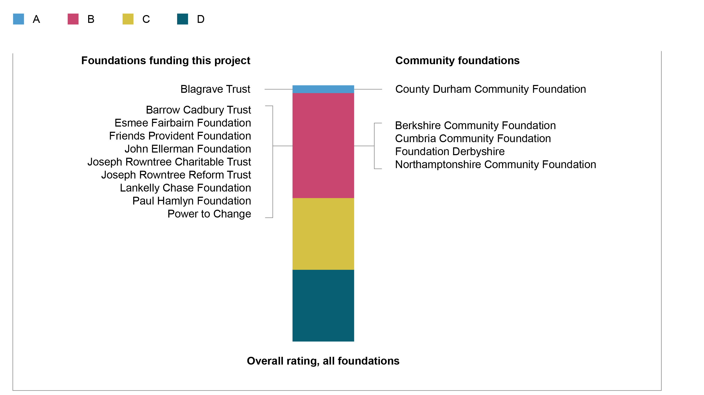

The distribution of overall scores in each pillar
The graphs in Figure 10 show the scores in each pillar. The bars are coloured according to the foundation’s overall score (i.e. not its score on that pillar). The distribution of scores in each pillar is quite continuous, i.e. there are no ‘clumps’ of foundations or large jumps in the scores, there are only some small discontinuities.
Therefore, the relationship between a foundation’s overall score and its score for each pillar was quite close across most of the foundations. Most foundations are pretty consistent in their practice: few are great at some things and very poor at others.
The graphs all have the same axis: notice how the scores on diversity are lower than those on the other pillars.

Figure 10: Distribution of scores in each pillar (the bars are coloured according to each foundation’s overall rating, not the pillar rating)
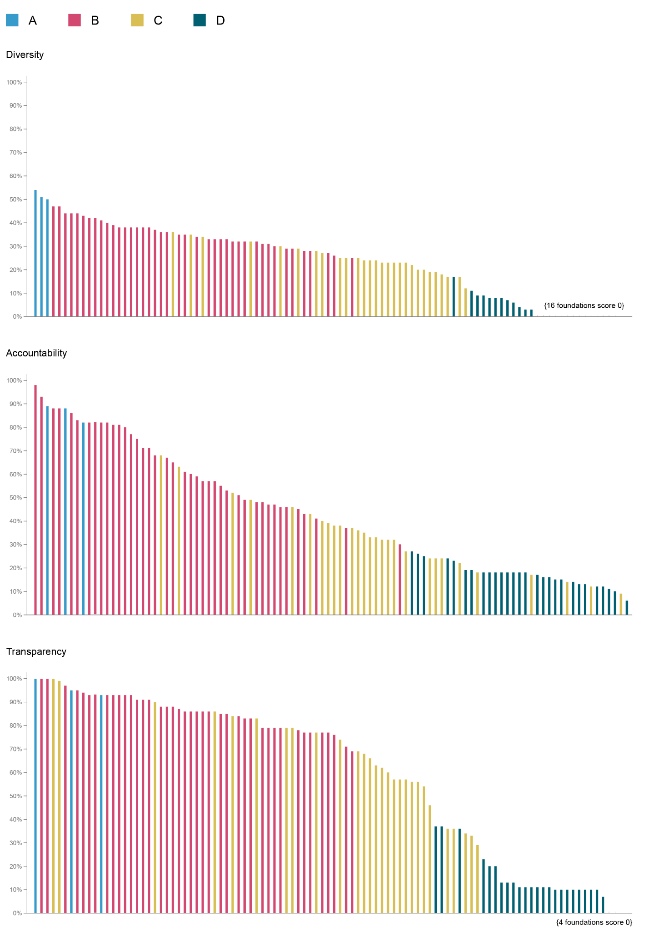
Although presenting the results by type of foundation might have been interesting, a decision was taken not to do so in this report because of the difficulty in deriving a robust categorisation. Giving Trends 2019 (Association of Charitable Foundations) splits foundations into corporate, family and other. But even this has some oddities – for example, it classifies the Wellcome Trust as a family foundation, which it is not. And there are plenty of grey areas – consider, for example, a corporate foundation of a company wholly owned by one family which appoints the senior staff and hence the board. It was not entirely clear to the research team whether this made it a corporate foundation or a family one. Therefore, this analysis is not pursued in this report.

Does size matter?
The findings show that financial size does not affect foundations' rating on the FPR, but that size by number of staff and trustees does.

Financial size
When the included foundations were divided into quintiles by giving budget and net assets, practice of all standards (i.e. all ratings) was found in each quintile.
There was no relationship between the foundations’ giving budget and their overall rating – each quintile had a mix of overall scores (see the left-hand graphs in Figure 11).
There was also no obvious correlation between foundations’ net assets and their overall scores – again, each quintile had a mix of overall scores (see the right-hand graphs in Figure 11)
In both cases, there is no obvious correlation between a foundation’s overall score and its size.

Figure 11: Overall scores of foundations ordered by financial size (giving budget on the left; net assets on the right)
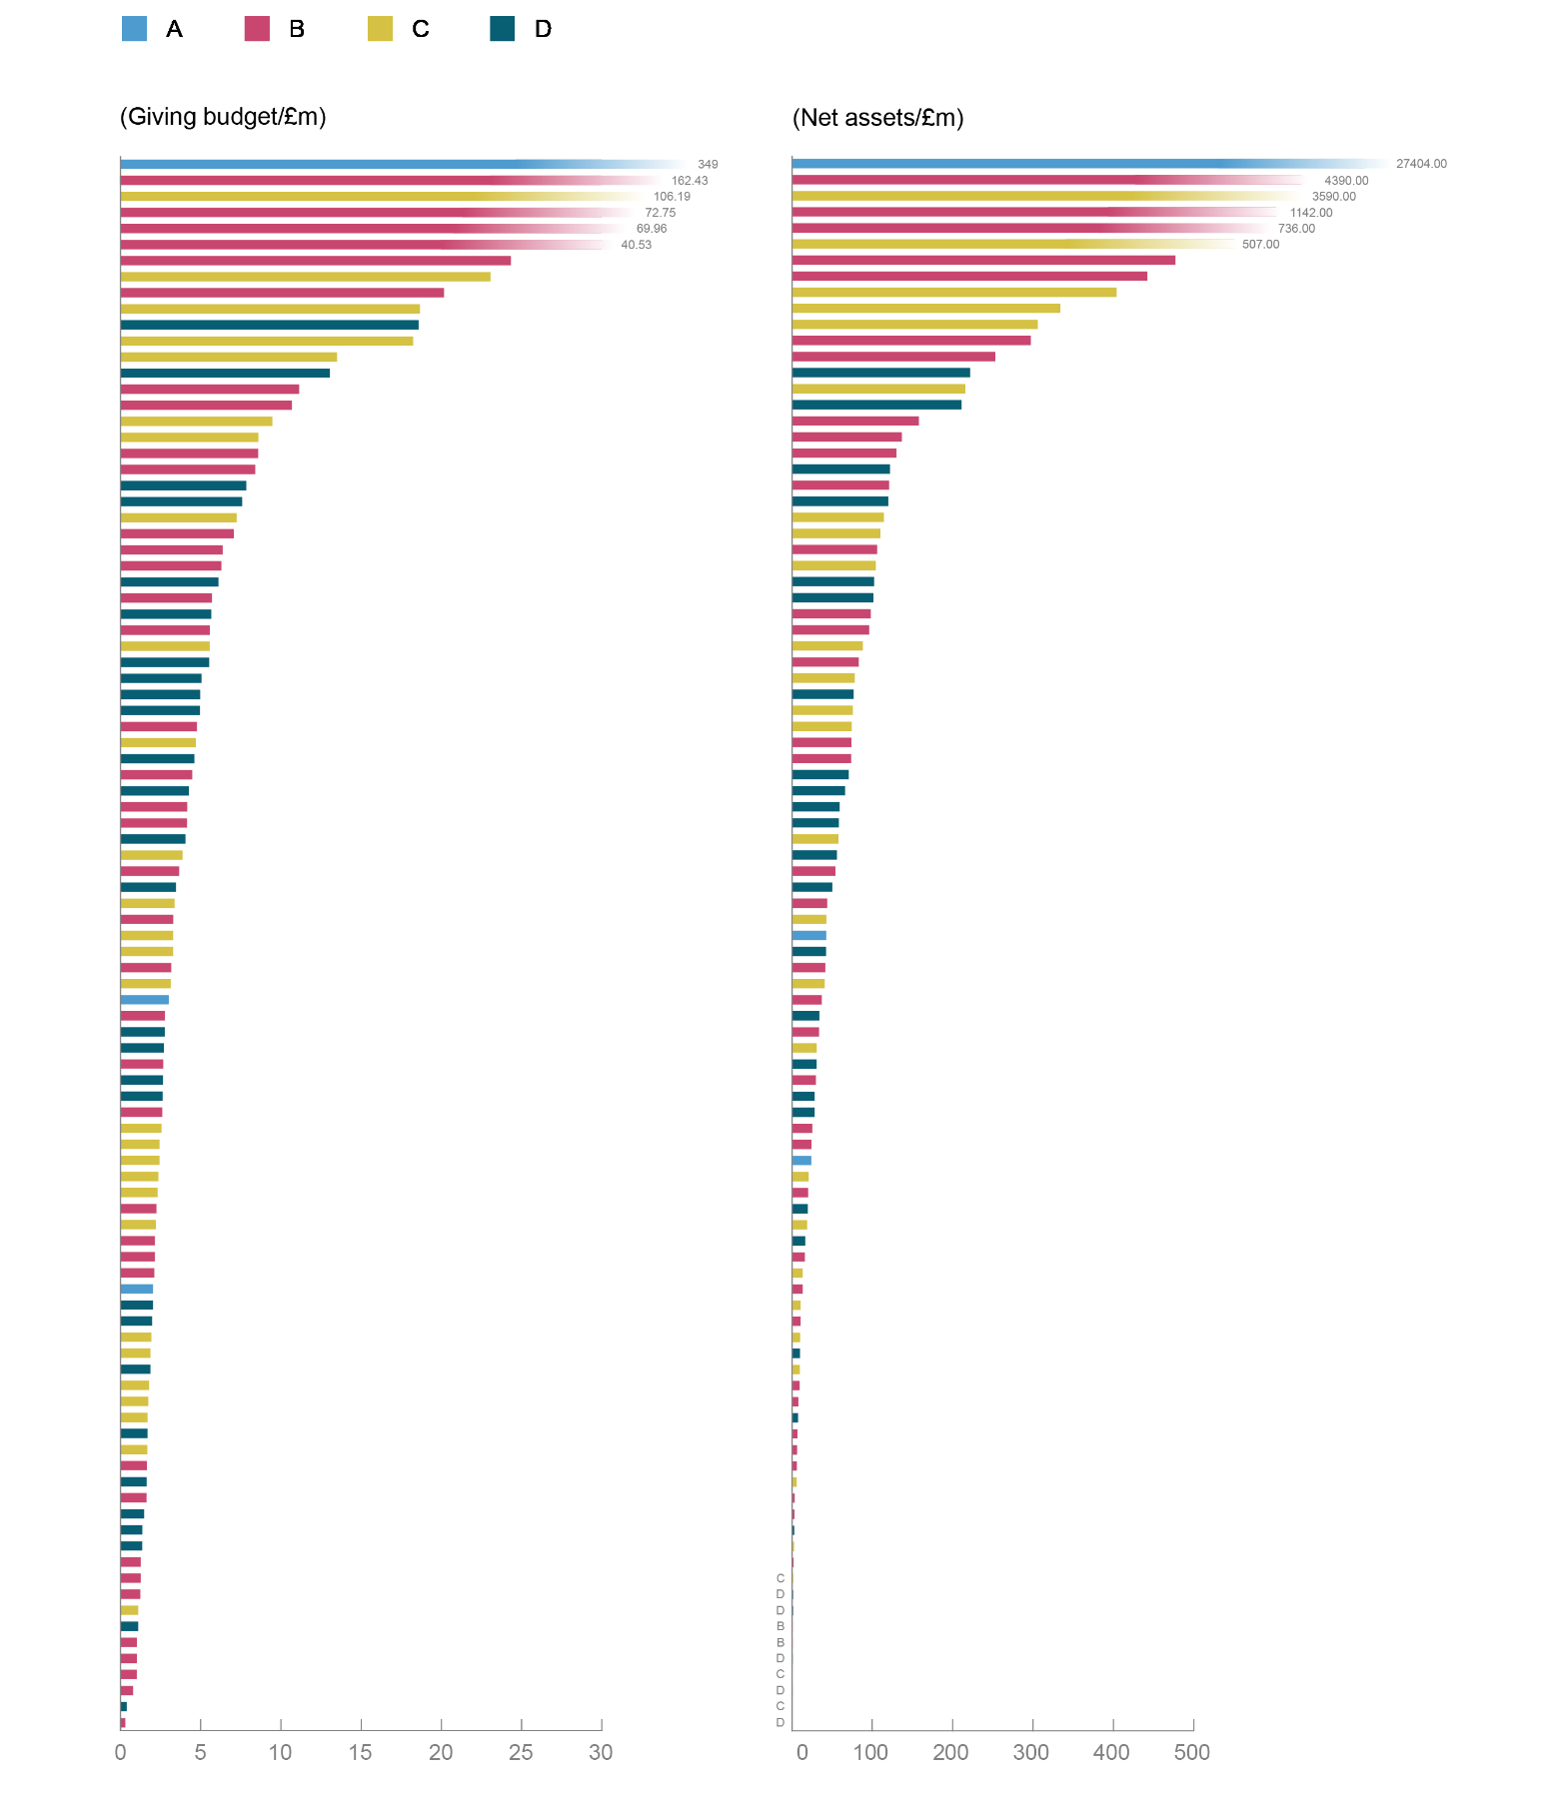
(Note: Joseph Rowntree Reform Trust and Power to Change are not included in these graphs as they are not charities and are therefore at liberty to work differently.)

Team size
There was some correlation between the number of staff and the overall score (also discussed in Appendix F, page 65). As Figure 12 shows, foundations with no staff tended to score lower than foundations with some staff. This pattern is perhaps unsurprising, because it would suggest that they have less capacity to make and disclose policies.
On the other hand, having very many staff does not correlate with higher overall scores: foundations with 1–50 staff were more likely to score B than were foundations with 51–99 staff.
Figure 12: Breakdown of overall scores by number of staff in each foundation
(Within each band of number of staff, the percentage of foundations with each overall rating)
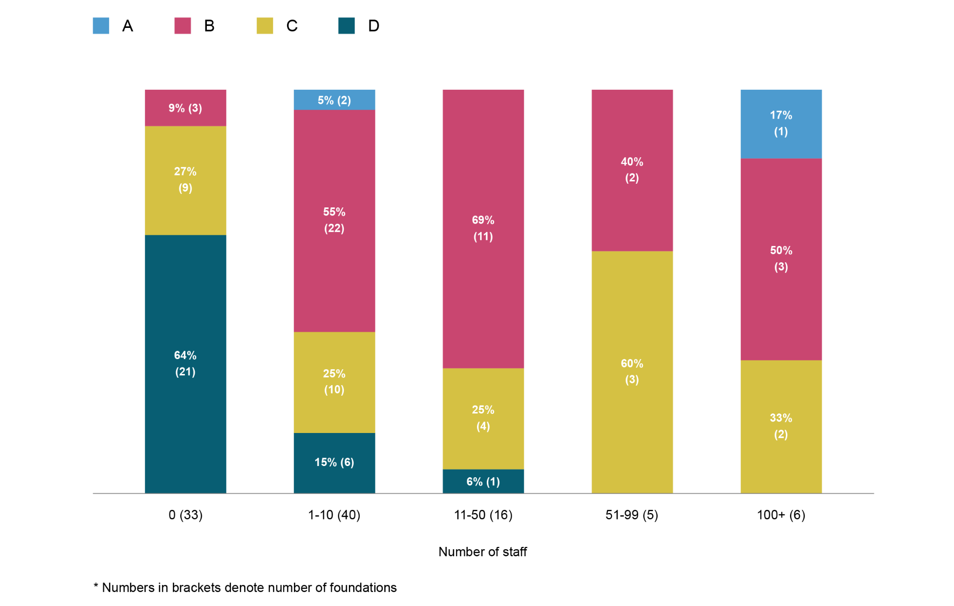
On the number of trustees, this showed a similar pattern to staff size. Foundations with five or fewer trustees tended to perform worse – over half scored D overall (Figure 13). There appears to be a relationship between having more trustees and scoring better, particularly on accountability. It is unclear why such a relationship might exist; this is discussed further in Appendix F (page 65).
Figure 13: Breakdown of overall scores by number of trustees at each foundation
(Within each band of number of trustees, the percentage of foundations with each overall rating)
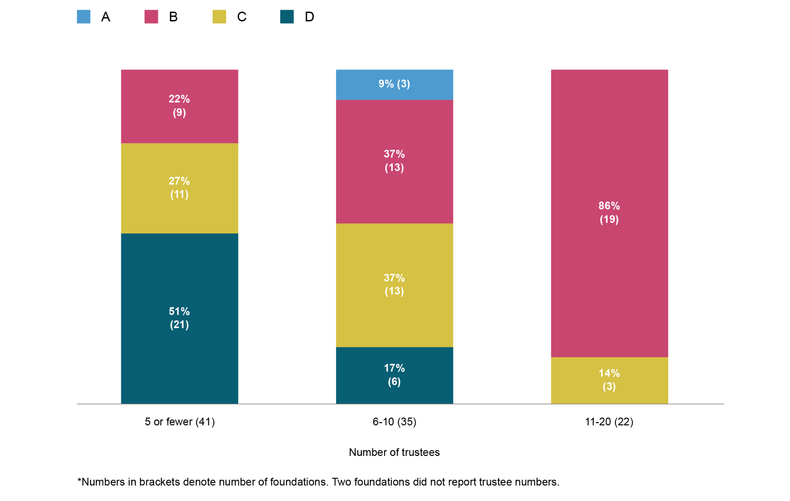

Low scores aren’t confined to small foundations
Twenty-eight foundations scored D overall. Indeed, 22 of these scored D on all three pillars. This is a large proportion, given that only 100 foundations were assessed. They spanned the size range (in terms of giving budget), with some in each quintile. None of the foundations that scored D on all three pillars had a website, and about 40 per cent of them did not provide an email address (so the data about them had to be sent to them by post).

Criteria on which foundations scored highest
The following are the criteria on which the foundations collectively performed best. Only one is in the diversity pillar.
Figure 14: Questions on which the foundations collectively scored highest
Question number | Question | Pillar
87  (highest score) | Does the foundation have an investment policy? | Accountability
29 | Does the foundation give any information on who or what it has funded? | Transparency
88/89 | The number of items stated in a foundation’s investment policy (maximum of eight). | Accountability
40 | Does the foundation publish who its staff are on its website? (This can be senior staff only or all staff – either is a ‘Yes’.) N/A if they have no staff – this can usually be verified on the relevant charity regulator’s website. | Accountability
32 | The number of items of information provided about the awarded grants? a) name of grantee, b) award date, c) description/title, d) amount awarded and/or e) duration. | Transparency
2 | Does the foundation have a website? | Transparency
8 | Does the foundation publish on its website any information about its funding priorities? | Transparency
68 | Is there contact information provided on the foundation’s website? If the foundation has no website, the answer is ‘No’. | Transparency
4 | Can you navigate the foundation’s website using only the keyboard (without a mouse)? If the foundation doesn’t have a website, enter ‘No’. | Diversity
11 | Does the foundation state how to apply for funding? | Transparency

Criteria on which foundations scored lowest
The following are the criteria on which the foundations collectively performed least well. Notice that this list is almost entirely about diversity.
Figure 15: Questions on which the foundations collectively scored lowest
Number | Question | Pillar
60  (lowest score) | Does the foundation publish a breakdown of the diversity of its trustees/board members? (With respect to gender, ethnicity and disability only) | Diversity
65 | The number of items included in the foundation’s plan to improve the diversity of its trustees/board members, e.g. targets for women, BAME staff, LGBTQIA+ and/or disabled trustees. | Diversity
63 | Does the foundation’s plan to improve the diversity of its trustees/board members include specific, numerical targets? | Diversity
35 | If the foundation funds recipients in Wales, is a Welsh language format provided? ‘N/A’ if the foundation does not have a presence in Wales. | Diversity
55 | The number of items included in the foundation’s plan to improve the diversity of its staff, e.g. targets for women, BAME staff, LGBTQIA+ and/or disabled staff. | Diversity
78 | The number of ways given for contacting the foundation concerning malpractice. e.g. email, phone number, online form, mailing address, web chat, BSL, text relay or any others. | Diversity
53 | Does the foundation’s plan to improve the diversity of its staff include specific, numerical targets? | Diversity
72 | The number of ways that the foundation gives to contact it if you are disabled? (Text relay, BSL or other) | Diversity
76 | Is there a mechanism to report malpractice concerns (whistleblowing)? | Accountability

Do as I say, not as I do
In several cases, foundations required something from their grantees that they did not seem to do themselves. Examples include:
- foundations requiring grantees to have complaints procedures or whistleblower procedures, but not having them themselves (that could be found);
- foundations requiring grantees to commit to paying the Living Wage but not themselves having a public commitment to doing so (that could be found);
- foundations requiring grantees to consult with the communities they serve (e.g. in determining their priorities) but not reporting that they do so themselves (that could be found).
Another anomaly is foundations requiring grantees to produce evidence and analysis of their impact and success, but the foundation not producing this about itself. For example:
- Only 20 per cent of the foundations reported feedback from their grantees.
- Only 12 per cent provided any information about actions they would take as a result of this feedback.
- Only 35 per cent produced any analysis of effectiveness. This is certainly not unique to UK foundations. A standard reason that foundations give is that analysing a grant-maker’s impact can be difficult because its effects are vicarious through its grantees. However, there are plenty of things that a foundation can – and should – analyse to measure its success. An example is the proportion of grants (by programme) that meet their primary goal(s) versus those that don’t. They can then compare that to the characteristics of the grants/grantees, which will show whether they succeed most often with grants in (say) Wales or Scotland, or small grants versus larger grants, or small grantees versus larger grantees, and so on. Almost all foundations’ work could be analysed in this way, and it would give great insight into how they can be most effective. (Giving Evidence’s Director Caroline Fiennes has written extensively about how grant-making foundations can assess their effectiveness – as have others.)

Examples of great practice
The research encountered some practices that seem particularly creditable. Some are cited here to inspire other foundations to emulate them and to demonstrate what is possible.
Figure 16: Examples of particularly good practice
Practice | Foundation
An appeals process for rejected applicants.  (The research team had never even heard of a foundation having this!) | County Durham Community Foundation
Easy to expand the font on the whole website.  There are easy-to-find buttons atop the website that expand the font on all of its pages. | Cumbria Community Foundation
Website contains accessibility tools, equipped with ReciteMe plug-in. | Lankelly Chase Foundation
Extensive information on contact for disabled users, with assistive technology, and including a £500 bursary for those needing help with applications. | Paul Hamlyn Foundation
Good, clear presentation of funding priorities in various formats – PDF, video and slideshow. | Lloyd’s Register Foundation
Complaint policy includes introduction; definition of a complaint; acknowledgement of complaint receipt; investigation; second stage investigation; and final stage investigation. | Berkshire Community Foundation
Feedback/complaints form includes who to contact and how; how it will respond; timing; and a confidentiality statement. | Islamic Aid
Each fund has a pdf of applicant guidelines that covers funding priorities. | Drapers’ Charitable Fund
Impact Report 2020 and Gardens and Coronavirus 2020 report contain good analysis of effectiveness. | National Gardens Scheme Charitable Trust
Contact details provided for all the grant team members in all regions of operation. | Lloyds Bank Foundation for England and Wales
Pay gap data provided by a relatively small foundation (it was exempted from this criterion in the scoring). | Barrow Cadbury Trust
Provides very clear evidence about how it increased the type and range of grants in order to address the concerns that arose from its own impact analysis. | Clergy Support Trust

Other findings by pillar
In terms of overall rating, the foundations that scored highly were of various sizes. This suggests that foundation size, including having a relatively large budget, is not necessarily a prerequisite for good practice in diversity, accountability or transparency.
On diversity, no foundation scored A. In fact, the overall rating of eleven foundations that scored highly on both transparency and accountability was negatively affected by low scores on diversity.
The main reasons for low scores in this pillar included:
- Though many foundations publicly affirmed their commitment to equality, diversity and inclusion, and provided statements indicating a willingness to improve, few of those statements contained clear targets or goals for how they intended to improve diversity over time. A statement is not a plan.
- Few foundations publicly reported the diversity of their staff team or board. This issue was so widespread that it was not possible to collect sufficient data. While this kind of reporting may not be desirable for smaller foundations with few staff, foundations with larger teams could report it. Again, some foundations reviewed and critiqued the composition of the staff and boards of organisations whom they assessed for funding, but did not apply that test to themselves. By contrast, 48 per cent of FTSE 250 firms reported a board diversity policy.
- Many foundations’ websites could be much more accessible. Though most met minimum requirements for visually impaired people, and some made provisions for people with dyslexia, many presented in only one format, either text or pictures. This limits choices for people with different needs about how best to engage. For instance, few foundations offered contact options such as text relay and/or a service like SignVideo. And it was more common for foundations to only offer one way to apply, for example using an online application, than it was to offer several application routes. Additionally, few of the foundations that fund in Wales provided information in Welsh. This falls below the standards of many public sector bodies.
On accountability, far more foundations in the sample scored C or D than scored A or B. Few provided an obvious mechanism for people to make a complaint or to raise concerns via their websites. Some did not even provide a contact email or phone number. For those foundations in particular, communication may well be only one-way: they appeared not to be inviting or open to input or contact from stakeholders.
On transparency, just over half of the foundations assessed scored A. Given that the data that was measured was based on publicly available information, this may not be wholly surprising. However, there was a broad spread of results on transparency, and some foundations scored poorly. Reasons for poor performance on transparency included not providing a website at all, or providing a website that was not user-friendly or had little information. For instance, some foundations’ websites were cluttered with pictures or text, which can impede finding information. Other sites were too sparse – potentially visually attractive but not specifying how to apply or what the foundation funded.
These findings suggest that more foundations should proactively work with disabled people to review their websites and practices to ensure that they are not disadvantaging disabled applicants and potential future staff.
In the coming years, hopefully the findings from the FPR can support improvement across the sector, in particular on issues relating to diversity.

04. Reactions from foundations
Each included foundation was sent the the information gathered about it, so that it could suggest corrections and point out anything that had been missed.
Most of the included foundations had not asked to be included. In addition, the previous two years had been incredibly busy and difficult for all foundations because of the Covid-19 pandemic. Many were coping with a rise in need, staff shortages and suddenly moving to working from home, to name a few challenges, and many had radically adapted their processes to the crisis. In addition, UK community foundations were undergoing Quality Accreditation – a detailed process – around the same time as receiving the unsolicited information from the FPR.
Given all that, the response from foundations was very encouraging.

Helpful pointers for improvement
Many of the foundations that responded said the data and process were helpful to them. Here are some typical comments. Starred comments are from the Funders Group, who supported the project and were expecting the data. All other comments are from foundations who were not expecting the data.
“[This] has got us thinking a lot about how we improve here – which there is clearly plenty of room for! I am new in post as CEO, and we are developing a new strategy – so a timely opportunity to give this more thought and focus.”
“We are always looking for ways to improve our processes and welcome this project.”
“I…am please[d] that we’ve been ‘picked out’. We’re very much committed to becoming a more accessible funder and only today were discussing our plans to progress various aspects of work in connection with this. Having looked at the survey [set of criteria], it gives us some useful pointers for consideration for improvement.”
“I will certainly be discussing with the trustees areas that we are not currently covering, with a view to seeking to address this in the coming months.”
“Good to have these [data on the foundation’s score on each criterion]…it is already, as hoped, giving us a list of things to get on with over the next year. Good for helping us to see what is obvious to us but not so to others visiting the website.” *
“We relaunched our website [recently], and your research will provide some much-needed focus for the next stage of its development, as well as iron out some glitches. So your feedback is really timely and helpful.” *

A tool for self-assessment
Some foundations reported using the set of criteria for self-assessment and hence guiding their work. For instance:
“We used what you’ve published around the rating system as a tool for self-assessment yesterday. It was very helpful in high[ligh]ting some things to do – some simple and obvious, some requiring a little more thought.”
This is particularly encouraging, because the criteria were not designed nor envisaged as a self-assessment tool. This feedback indicates that the FPR can make a difference in multiple ways, including ways other than was planned, and that it can spur change even in foundations outside the sample (i.e. there are multiple theories of change/routes to impact taking place).

Not a grant-making foundation
A surprise was that a few foundations in the sample responded by saying that they are not grant-making foundations and therefore should not be included. As mentioned, all of the included foundations were either on the ACF’s list of grant-making foundations in its Foundation Giving Trends 2019, or were community foundations. (None of the foundations who responded this way were community foundations.)
One or two of the foundations who made this response make grants but only to specific communities of grantees. It is possible that they mistook the FPR as pertaining only to open, responsive grant-makers (which receive applications from anybody).
Giving Evidence corresponded with each of these foundations, and relayed their concerns to the ACF for consideration in future iterations of its research. Because of the FPR’s policy of pushing decisions away from the research team, the research persisted with the set of foundations in the ACF’s report.

A prompt to amend priorities
Several foundations said that the criteria included issues they had been meaning to address for a while but had never actioned. They said that this rating would bump those items up the agenda and ensure that they are done soon.
Some foundations said that some of the criteria raised issues that they had never hitherto considered but could now see the value in doing. Making their materials available in Welsh is one example.

05. Next steps

Next year’s research and analysis
Foundation Practice Rating will run again in 2022–23. The details have yet to be finalised but the following is envisaged.
The included foundations will comprise:
- the foundations funding the work;
- the five largest UK foundations by giving budget;
- a fresh sample of other foundations drawn from the ACF’s most recent published list of UK grant-making foundations, and the most recent list of UK community foundations. It will, again, be a stratified random sample.
There is a good chance that foundations in the general sample will be included in the next iteration (even if they are not funding this work nor in the five largest), simply by weight of numbers: the sample is 100 foundations drawn from a set of only 383.
It is likely that the criteria for the second FPR will be largely the same as for the first year. That is for obvious reasons of continuity and enabling comparison. That said, the set, or individual questions, may be refined in the light of experience and feedback. Our plan is to open the consultation on the criteria to comments in Spring 2022.
The ‘grade boundaries’ may remain the same as for this first year. An alternative is to raise the bar for the rating bands in future, on the basis that by the second or third year foundations have had more time to make improvements to their practice and disclosure, and expectations should accordingly be higher.

Assessing the impact of this rating project
Accurately and comprehensively identifying the effect of this project will be impossible. This is for two reasons.
First, there is no counterfactual: the FPR ‘operates on’ the whole UK foundation sector – and does so quite deliberately – for instance by publishing the FPR criteria and stating publicly that the rating is being carried out, and that any foundation might be assessed in any year. There are therefore no foundations that are outside what researchers call the ‘treatment group’ (i.e. who are not affected by the project). This precludes any comparison of changes in performance of foundations who are ‘treated’ (i.e. assessed) with changes in performance of foundations who are not – everybody is treated.
Consequently, it is not possible to distinguish between the effects of this rating and the effects of other factors that affect foundations. It may be possible, over time, to track changes in foundations’ practices, but it won’t be possible to identify which changes arise because of this rating. Any observed changes could be due to factors that affect all foundations – for example the Black Lives Matter movement or changes in regulation or in societal attitudes.
Second, there is no ‘baseline’ data. The data gathered in this first year was gathered after the criteria and guidance on ‘how to do well’ were published: that is, after the intervention started. There is no way of knowing (unless they say so) whether any or all of the assessed foundations changed their practices and public documents in response to the criteria and guidance but before the formal data gathering was carried out. And that is fine: the organisations that initiated the FPR are more interested in using it to encourage change than in documenting change and attributing it.
That said, as discussed, many foundations have said that they find value in this process and the criteria. The FPR will continue to track these anecdotes and hope that the process continues to create value for the sector.
Feedback
Friends Provident Foundation welcomes feedback about this project. That can include your views about the process or the results; or if your foundation is now changing its practice as a result.
Please contact Jake Furby at jake.furby@friendsprovidentfoundation.org.uk

Appendices

A. Background on ratings systems from which some criteria were drawn

The Racial Equality Index
The Racial Equity Index (REIndex) Group was formed by a group of BIPOC people (Black, Indigenous and People of Color). The purpose of the Racial Equity Index is to produce an index and advocacy tools that will ‘provide greater accountability for racial equity within and across the global development sector in order to dismantle structural racism and create a more equitable system and culture, with justice and dignity at its core’.

Give.org’s BBB Wise Giving Alliance: Standards for Charity Accountability
Give.org’s BBB Wise Giving Alliance is a 501(c)(3) public charity in the US that works to help the public to identify trustworthy national charities by evaluating them rigorously in relation to the 20 BBB Standards for Charity Accountability (which address four areas of charity accountability: governance, results reporting, finances and transparent communications).

Funders Collaborative Hub: DEI Data Standard
The DEI Data Group is an independent working group that includes a range of foundations and funders from across the UK. In August 2020 the DEI Data Group commissioned 360Giving and the Social Investment Consultancy to develop a framework to monitor equity considerations in grant-making, with a view to including the data in published grants information.
The DEI Data Group also included input, engagement and consultation with a diverse range of specialist infrastructure organisations, organisations working on social justice issues, and the wider sector to try to reflect, as far as possible in a unifying framework, how organisations identify themselves.
The final framework is not meant to judge organisations, but to help identify the different categories that funders could use to collect data in a systematic manner, to gauge how equitable their funding and funding practices are.

Social Mobility Foundation: Social Mobility Employer Index
The Social Mobility Employer Index, established in 2017, is a benchmarking initiative that ranks Britain’s employers on the actions they are taking to ensure they are open to accessing and progressing talent from all backgrounds and it showcases progress towards improving social mobility. The methodology was developed in collaboration with the Bridge Group, a non-profit consultancy that uses research to promote social equality. Employers are benchmarked against one another based on the results.

Candid: GlassPockets Transparency Standard
GlassPockets is an initiative that ‘champions philanthropic transparency in an online world’. It provides the data, resources, examples and action steps foundations need to understand the value of transparency, be more open in their own communications, and help shed more light on how private organisations are serving the public good.
In order to participate, foundations must complete a self-assessment form concerning how their practice relates to a suite of transparency indicators provided by GlassPockets. The team at GlassPockets will then review this self-assessment and publish it, if the foundation agrees.

B. Example of foundations that exhibit each item assessed
Figure 17 lists each item on which the FPR assessed each foundation (e.g. a diversity plan with numerical targets, a complaints policy, an analysis of its own performance). For each item, the table lists an example foundation that exhibited it. This demonstrates that everything being sought is attainable: every item was attained by at least one of the 100 foundations assessed.
Figure 17: The items that were sought and an example foundation for each
Question no. | Item | Example foundation
2 | Website | The Albert Hunt Trust
4 | Ability to navigate the foundation’s website using only the keyboard (without a mouse) | Greggs Foundation
5 | Ability to zoom to 400% on any page on website and still read all of the text in a single column (the text and images don’t overlap / fall off the page) | The Maitri Foundation
8 | Information about the foundation’s funding priorities published on its website | KPMG Foundation
11 | Clear statement from foundation on how to apply for funding | Joseph Rowntree Reform Trust
12 | Ability to submit proposals in a range of formats | Lankelly Chase
16 | Eligibility criteria for funding published on foundation’s website | Power to Change
20 | Information on what the foundation will not fund explicit on its website | Charles Hayward Foundation
21 | Explicit mechanism for potential grantees to ask questions about funding also on foundation’s website | Northamptonshire Community Foundation
23 | Clear information provided on the foundation’s website on the time frame for funding decisions | Nuffield Foundation
25 | Information on the time frame in which the foundation will disburse its funding | Foundation Derbyshire
26 | Information on the criteria on which the foundation’s funding decisions are made | The Swire Charitable Trust
27 | Information about who within the foundation makes funding decisions | Indigo Trust
29 | Information on who or what the foundation has funded | Franciscan Missionaries of the Divine Motherhood
33 | Data on grants awarded provided in a downloadable (open) format (not requiring payment to access)... | Halifax Foundation for Northern Ireland
34 | … and that data (on grants awarded) is available for download at 360Giving | The Dunhill Medical Trust
35 | Where a foundation funds in Wales, a Welsh language format is provided | BBC Children in Need
36 | Information provided on funding success rates | The Leverhulme Trust
38 | Information published on grant reporting requirements for grantees | Eveson Charitable Trust
39 | Information published on any branding requirements for grantees | London Marathon Trust
40 | Publication on website of the foundation’s staff | Burdett Trust for Nursing
41 | Publication of senior staff bios on foundation’s website | Friends Provident Foundation
45 | Publication on website of the foundation’s trustees/board members | Foyle Foundation
46 | Publication of trustee bios on foundation’s website | Steve Morgan Foundation
50 | Foundation publishes a breakdown of the diversity of its staff | Barrow Cadbury Trust
52/53/54 | Existence of a plan for the foundation to improve the diversity of its staff.  Plan includes specific, numerical targets to improve diversity; including targets for women, BAME staff, LGBTQIA+ and/or disabled staff | Wellcome Trust
56 | Foundation publishes information on any pay gaps (gender, ethnicity, disability) | Barrow Cadbury Trust
58 | Foundation has made a public commitment to be a Living Wage Employer | Joseph Rowntree Reform Trust
60 | Foundation publishes a breakdown of the diversity of its trustees/board members (with respect to gender, ethnicity, diversity only) | The Rhodes Trust  (ethnicity only)
62/63/64 | Existence of a plan for the foundation to improve the diversity of its trustees/board members  Plan includes specific, numerical targets to improve diversity; including targets for women, BAME, LGBTQIA+ and/or disabled trustees | The Joseph Rowntree Charitable Trust
66 | Foundation publishes its recruitment policy for staff | Ogden Trust
67 | Foundation publishes its recruitment policy for board members | Raphael Freshwater Memorial Association
68 | Contact information provided on the foundation’s website | James Dyson Foundation
71 | Different ways to contact the foundation for people who are disabled | Paul Hamlyn Foundation
73 | Foundation provides a mechanism for comments, complaints (feedback)  (This is over and above simple contact information) | Scottish Catholic International Aid Foundation
76 | Foundation provides a mechanism to report malpractice concerns (whistleblowing) | Baron Davenport’s Charity
79 | Publication of any feedback that the foundation receives from grant-seekers and/or grantees? | Comic Relief
80 | Publication of any actions the foundation will take to address this feedback (what it is doing differently as a consequence) | John Ellerman Foundation
81 | Foundation publishes some analysis of its own effectiveness | Esmeé Fairbairn Foundation
83 | Foundation publishes information on what it is doing differently as a consequence of this analysis | CIFF: Children’s Investment Fund Foundation
85 | Evidence that the foundation, in determining its funding priorities, has consulted the communities it seeks to support | The Blagrave Trust
87 | Publication of the foundation’s investment policy | The Legal Education Foundation
88 | Investment policy includes:  - the scope of the foundation’s investment powers;  - its investment objectives;  - its attitude to risk;  - how much is available for investment, timing of returns and its liquidity needs;  - the types of investment it wants to make; this might include ethical considerations;  - who can take investment decisions;  - how investments will be managed and benchmarks and targets by which performance will be judged;  - reporting requirements for investment managers. | The Royal Navy and Royal Marines

C. Detailed criteria in the FPR
Figure 18 sets out the FPR’s questions that researchers answer about each foundation. Most of these translate into criteria, on which the foundation is assessed. The table also shows the ‘pillar’ (diversity, accountability, or transparency) to which each criterion contributes.
As discussed, not all questions apply to all foundations. Some examples are foundations that only fund by invitation, have no staff, or have a low number of trustees. In such cases, that foundation is exempt from that criterion: it receives no marks, but the calculation of the overall percentage also removes those questions from the potential total score. This means that if foundations achieve a perfect score on all the questions that apply to them, they will receive 100 per cent.
Figure 18: Criteria used in the assessment, and the scoring system
Pillar | Qn | Question | Value | Comments
– | 1 | Write down the name of the foundation. | – | –
Transparency | 2 | Does the foundation have a website? | 1 | –
– | 3 | If yes, insert the url. If there is no website, write ‘None’. | – | –
Diversity | 4 | Can you navigate the foundation’s website using only the keyboard (without a mouse)? If the foundation has no website, enter ‘No’. | 1 | –
Diversity | 5 | Can you zoom to 400% on any page within the foundation’s website and still read all of the text in a single column (the text and images don’t overlap or spill off the page)? If the foundation has no website, enter ‘No’. | 1 | –
– | 6 | Is the foundation current on the Charity Commission for England and Wales, the Office of the Scottish Regulator or The Charity Commission for Northern Ireland (within the last 24 months)? | – | No score, information only
– | 7 | Which charity regulator did you use to find the foundation’s information? Charity Commission for England and Wales (CCEW), Office of the Scottish Regulator (OSCR) or Charity Commission for Northern Ireland (CCNI)? | – | CCEW, OSCR or CCNI
Transparency | 8 | Does the foundation publish on its website any information about its funding priorities? | 1 | –
– | 9 | How many ways does the foundation present its funding priorities – PDF, web text, video, via public forums or other? Write down all that apply or ‘None’ if there is no information. | – | –
Diversity | 10 | How many items did you write down for the question above? (If there are none, enter ‘0’) | 1 | Cap at 1, downloadable doc (0.25), web text (0.25), video/slides/  audio (0.25), public meetings (0.25)
Transparency | 11 | Does the foundation state how to apply for funding? | 1 | Exempted if proposals are solicited
Diversity | 12 | Is it possible to submit funding proposals in a range of different formats? Enter ‘No’ if there is no information given about how to apply or if there is only one way to submit an application. | 1 | Exempted if proposals are solicited
– | 13 | What different types of formats are accepted for proposals by the foundation? Hand-written, paper, video, audio, in-person, online meetings? If it is not clear how to submit a proposal, write ‘None’. | – | Exempted if proposals are solicited
Diversity | 14 | How many items did you write down for the question above? (If there are none, enter ‘0’) | 1 | First way (0.5), (0.25 for any other), max 1. Exempted if proposals are solicited
– | 15 | Does the foundation only fund proposals that it has invited (e.g. it does not accept unsolicited applications)? (The answer to this is automatically ‘No’ if the answer to the question above is greater than 0) | – | No score, information only
Transparency | 16 | Does the foundation publish any eligibility criteria for what it funds (that is, who as a potential recipient would be eligible for a particular grant)? | 1 | Exempted if proposals are solicited
– | 17 | How are the eligibility criteria presented? PDF, eligibility quiz, web text, video? Write down all that apply or ‘None’ if there is no information. | –
Diversity | 18 | How many items did you write down for the question above? (If there are none, enter ‘0’) | 1 | First way (0.5), (0.25 for any other). Exempted if proposals are solicited
Transparency | 19 | Approximately what percentage of all funding programmes have associated eligibility criteria presented for them?  Select one of the following scores:  0 = none, 1 = 1–25%, 2 = 26–50%, 3 = 51–75%, 4 = 76–99% or 5 = eligibility information provided for all funding programmes. | 1 | How to scale: all = 1  none = 0  0.2 for each point (eg 75% would be 0.6). Exempted if proposals are solicited
Transparency | 20 | Is the foundation explicit about what it will not fund? The foundation must state ‘we do not fund’ or ‘are not likely to fund’ (or similar) to score ‘yes’. | 1 | Exempted if proposals are solicited
Transparency | 21 | Is there an explicit mechanism to ask questions about funding (eg contact details for the relevant people or general contact for funding questions)? | 1 | Exempted if proposals are solicited
Transparency | 23 | Is there any information provided on a time frame for funding decisions? (This is distinct from application deadlines.) This must include either explicit dates or information such as ‘within four weeks after proposal submission’ or similar. |  | No score, redundant to Q24
Transparency | 24 | Approximately what percentage of the foundation’s funding programmes have associated timelines? Select one of the following scores: 0 = none, 1 = 1–25%, 2 = 26–50%, 3 = 51–75%, 4 = 76–99% or 5 = timelines are provided for all funding programmes. | 1 | How to scale: all = 1  none = 0  0.2 for each point (e.g. 75% would be 0.6). Exempted if proposals are solicited
Transparency | 25 | Does the foundation publish a time frame in which it will disburse the funds? | 1 | Exempted if proposals are solicited
Accountability | 26 | Does the foundation cite any criteria on which its funding decisions are made? | 1 | –
Accountability | 27 | Does the foundation say who makes the funding decisions in its organisation (the staff, the trustees, an external panel, or other)? | – | No score, redundant to Q28
Accountability | 28 | For approximately what percentage of the foundation’s funding programmes is information given on who made the funding decisions (either a panel or a person)?  0 = none, 1 = 1–25%, 2 = 26–50%,  3 = 51–75%, 4 = 76–99%, 5 = if this information is provided for all funding programmes. | 1 | How to scale – all = 1  none = 0  0.2 for each point (e.g. 75% would be 0.6). Exempted if proposals are solicited
Transparency | 29 | Does the foundation give any information on who or what it has funded? | 1
Transparency | 30 | If the answer to the question above is no, do they state why? Enter ‘N/A’ if the answer to question 29 is ‘yes’. | (1) | This automatically compensates for Q29, if there is no score for that question
Transparency | 31 | Is the following information provided about the awarded grants: a) name of grantee, b) award date, c) description/title, d) amount awarded and/or e) duration? Write down all that apply (do not include any not in the above list). | – | –
Transparency | 32 | How many items did you write down for the question above? (If there are none, enter ‘0’) | 1 | 0.2 for each item, max. 1
Accountability | 33 | Does the foundation provide its data on awarded grants in a downloadable (open) format that doesn’t require payment to access (.xlsx, .csv. .jstor, or .txt)? | 1 | This should be on either their own website or on 360Giving, but in that case they must say so on their website or on the charity register
Accountability | 34 | Does the foundation say it has made data available for download at 360Giving? | – | No score
Diversity | 35 | If the foundation funds recipients in Wales, is a Welsh language format provided? N/A if the foundation does not have a presence in Wales. | 1 | Exempt if N/A
Transparency | 36 | Are funding success rates provided? | 1 | –
Transparency | 37 | If not, is there a reason why (e.g. the foundation funds invite-only proposals or similar)? ‘N/A’ if the funding success rates are provided. | – | 1 if yes, 0 if N/A or no – automatically compensates for Q26
Transparency | 38 | Does the foundation publish information about any grant reporting requirements for its grantees? | 0.5 | Q38 and 39 were combined in the criterion in the consultation, so 0.5 each
Transparency | 39 | Does the foundation publish information about branding requirements for its grantees? | 0.5 | Q38 and 39 were combined in the criterion in the consultation, so 0.5 each
Accountability | 40 | Does the foundation publish who its staff are on its website? (This can be senior staff only or all staff – either is a ‘Yes’.)  N/A if there are no staff – this can usually be verified on the relevant charity regulator’s website. | 1 | Exempted if there are no staff
Accountability | 41 | Does the foundation provide a bio for its senior staff? N/A if there are no staff. | 1 | Exempted if there are no staff
Accountability | 42 | Is the following information presented in the bio: a) name, b) picture, c) previous job history, d) job title and e) contact information? Write down all that apply. | – | Exempted if there are no staff
Accountability | 43 | How many items did you write down for the question above? If there are none, enter ‘0’, if there are no staff ‘N/A’. This question has a maximum score of five things. | 1 | 0.2 per item, for a maximum  of 1.  Exempted if there are no staff
– | 44 | Write down the number of staff. Get this from the relevant charity regulator’s website (in the Charity Overview, under People). | – | –
Accountability | 45 | Does the foundation publish who its trustees/board members are on its website? This is ‘No’ if this information comes from a charity regulator’s website. | 1 | –
Accountability | 46 | Does the foundation provide a bio for its trustees/board members? | 1 | –
– | 47 | Is the following information presented in the bio: a) name, b) picture, c) previous job history, d) job title? Write down all that apply. | – | –
Accountability | 48 | How many items did you write down for the question above? If there are none, enter ‘0’; this question has a maximum of four things. | 1 | 0.25 per item (max. score 1)
– | 49 | Write down the number of trustees/board members. Get this from the relevant charity regulator’s website (in the Charity Overview, under People). | – | –
Diversity | 50 | Does the foundation publish a breakdown of the diversity of its staff (all staff, with respect to gender, ethnicity and disability only)? ‘N/A’ if they have no or one staff member. | 1 | 1 point for anything, gender, ethnicity and disability, reference Q below. Exempted if 10 or fewer staff
Diversity | 52 | Does the foundation have a plan to improve the diversity of its staff? ‘N/A’ if there are no staff or one member of staff. | 1 | Exempted if 10 or fewer staff
Diversity | 53 | Does this plan include specific, numerical targets to improve the diversity of its staff? ‘N/A’ if there are no staff or one member of staff. | 1 | Exempted if 10 or fewer staff
Diversity | 54 | Does this plan include targets for women, BAME staff, LGBTQIA+ and/or disabled staff? Write down all that apply or ‘No plan’ if there is not one. | – | Exempted if 10 or fewer staff
Diversity | 55 | How many items did you write down for the question above? If there are none, enter ‘0’, there is a maximum score of 4. If there are more than four items written down, leave them but only score ‘4’ as a maximum. | 1 | Max. 1, 0.33 for women, BAME staff and disabled staff- no score for  LGBTQIA+. Information on LGBTQIA+ was collected but not included in the scoring as it isn’t required by EHRC. Exempted if 10 or fewer staff
Diversity | 56 | Does the foundation publish information on any pay gaps (gender, ethnicity, disability)? ‘N/A’ if there are no staff. | 1 | Exclude if fewer than 50 staff
Diversity | 58 | Has the foundation made a public commitment to be a Living Wage employer? ‘N/A’ if there are no staff. | 1 | Exempted if no staff
Diversity | 60 | Does the foundation publish a breakdown of the diversity of its trustees/board members (with respect to gender, ethnicity and disability only)? | 1 | 1 for anything. Exempted if 5 or fewer trustees
Diversity | 61 | If yes, what is that breakdown? If no, write ‘None’. | – | No score
Diversity | 62 | Does the foundation have a plan to improve the diversity of its trustees/board members? | 1 | Exempted if 3 or fewer trustees
Diversity | 63 | Does this plan include specific, numerical targets to improve the diversity of its trustees or board members? | – | Exempted if 3 or fewer trustees
Diversity | 64 | Does this plan include targets for women, BAME staff, LGBTQIA+ and/or disabled trustees? Write down all that apply, or ‘None’ if there is no plan. | – | Exempted if 3 or fewer trustees
Diversity | 65 | How many items did you write down for the question above? If there are none, enter ‘0’. There is a maximum score of 4. If there are more than four items written down, leave them but only score ‘4’ as a maximum. | 1 | Max. 1, 0.33 for women, BAME staff and disabled staff – no score for  LGBTQIA+. Information on LGBTQIA+ was collected but not included in the scoring as it isn’t required by EHRC. Exempted if 3 or fewer trustees
Diversity | 66 | Does the foundation publish its recruitment policy for staff? ‘N/A’ if there are no staff. | 1 | Exempted if no staff
Diversity | 67 | Does the foundation publish its recruitment policy for board members? | 1 | –
Transparency | 68 | Is there contact information provided on the foundation’s website? If the foundation has no website the answer is ‘No’. | 1 | –
Transparency | 69 | Write down the different ways provided for contacting the foundation: email, phone number, online form, mailing address, web-chat, Facebook, Twitter, Instagram, etc. Write down ‘None’ if no contact information is provided. | – | –
Diversity | 70 | How many items did you write down for the question above? (If there are none, enter ‘0’) | 1 | Max. 1, online/email (0.25), phone (0.25), physical address (0.25) and social media (0.25)
Diversity | 71 | Does the foundation give ways to contact them if you are disabled (text relay, BSL or other)? Write down the different types of accessible contact (do not repeat any information from above). Write down ‘None’ if none are provided. | – | –
Diversity | 72 | How many items did you write down for the question above? (If there are none, enter ‘0’) | 1 | 1 for any mechanism, max. 1
Accountability | 73 | Does the foundation provide a mechanism for comments and complaints (feedback)? (This is over and above simple contact information.) | 1 | –
Diversity | 74 | Write down the different ways given for contacting the foundation concerning complaints: email, phone number, online form, mailing address, web chat or any others. Be sure to include BSL, text relay, etc., if available. Write down ‘None’ if no contact for complaints is provided. | – | –
Diversity | 75 | How many items did you write down for the question above? (If there are none, enter ‘0’) |  | Max 1, 0.33 for each item, even if more than 3 are present
Accountability | 76 | Is there a mechanism to report malpractice concerns (whistleblowing)? | 1 | –
Diversity | 77 | Write down the different ways given for contacting the foundation concerning malpractice: email, phone number, online form, mailing address, web chat, or any others. Be sure to include BSL, text relay, etc., if available. Write down ‘None’ if no contact for malpractice is provided. | – | –
Diversity | 78 | How many items did you write down for the question above? (If there are none, enter ‘0’) | 1 | Max. 1,  0.33 for each item, even if more than 3 are present
Accountability | 79 | Does the foundation publish any feedback it receives from grant seekers and/or grantees? (This must be feedback, e.g. suggestions for the foundation, not just statements of ‘thank you for the funding’) | 1 | –
Accountability | 80 | Does the foundation publish any actions it will take to address this feedback (what they are doing differently as a consequence)? ‘No’ if not, or if they do not report any feedback. | 1 | –
Accountability | 81 | Does the foundation publish any analysis of its own effectiveness? (This must be separate from the annual report and must be analysis and something, not just statements from grantees that ‘We are grateful for the funding’ or similar.) | 1 | –
– | 82 | Write down what this analysis is and where you found it (and the url, if possible) or ‘None’ if there is no analysis. | – | –
Accountability | 83 | Does the foundation publish some information on what it is doing differently as a consequence of this analysis? | 1 | –
Accountability | 84 | Write down what this information is and where you found it (and the url, if possible). | – | –
Accountability | 85 | Does the foundation cite any evidence that it has consulted the communities it seeks to support in determining its funding priorities? | 1 | –
Accountability | 86 | Write down what this information is and where you found it (and the url, if possible). | – | –
Accountability | 87 | Does the foundation have an investment policy? | 1 | Exempt if N/A
Accountability | 88 | Does this policy include the following (write down all that apply):  a) the scope of its investment powers;  b) the charity’s investment objectives;  c) the charity’s attitude to risk;  d) how much is available for investment, timing of returns and the charity’s liquidity needs;  e) the types of investment it wants to make (this might include ethical considerations);  f) who can take investment decisions (e.g. trustees, an executive, an investment adviser or manager);  g) how investments will be managed and benchmarks and targets set by which performance will be judged;  h) reporting requirements for investment managers (if applicable; make a note in the comment box if it is not applicable). | – | –
Accountability | 89 | How many items did you write down for the question above? If there are none, enter ‘0’, if there is no investment policy enter ‘N/A’. There is a maximum score of 8 for this question. | 1 | Cap at 1. This means 0.125 point for each item that they have. 0 if none.  Note that item (h) if not applicable counts as 0.125
_ | 90 | Write down the income/net assets for the foundation from the most recent published accounts (in £ or specify if in another currency). | – | –

D. Eliminated criteria
During the research process, some criteria proved unworkable and were therefore eliminated.
Figure 19: Criteria that were eliminated during the research process
Question number | Question | Reason for elimination | Stage of elimination
N/A | Does the foundation fund any research (stand-alone research, not monitoring and evaluation of grantees that deliver services for other funding)? | Very few foundations did ‘research’ and research was difficult to  define | After benchmarking, before main data collection
N/A | If yes, write a brief description of the research they fund (e.g. ‘health’, ‘medical’, ‘environmental’ or other) or write ‘N/A’ if the foundation doesn’t fund research. | Same as above | Same as above
22 | Does the foundation explicitly ask potential grantees not to contact them (e.g. statements such as ‘Please read the FAQs, we are too busy to answer the phone’)? | This was a ‘negative’ question (this would have taken away points). Too subjective for accuracy in the data collection | Scoring stage
51 | If the foundation publishes a breakdown of the diversity of their staff, what is that breakdown? | The original intention was to compare the reported diversity of staff to national or regional demographics of the foundation. This proved too difficult because of the wide range of communities served. Also very few reported the staff breakdown | Scoring stage. Eliminated from scoring, but data still collected
61 | If the foundation publishes a breakdown of the diversity of their board/trustees, what is that breakdown? | Same as above | Scoring stage. Eliminated from scoring, but data still collected
57 | Does the foundation publish its pay policy (such as tax, sickness, holiday entitlement, maternity, paternity, shared parental leave or other)? ‘N/A’ if there are no staff. | Could not reliably collect data on this, as it was only clear for foundations that had a live job advertisement during the assessment period | Scoring stage
59 | Does the foundation state a policy of publishing salaries for any job advertisement (or is this clear in any current job announcement)? ‘N/A’ if there are no staff. | Same as above | Scoring stage

E. Exemption rules
Figure 20: Conditions under which various questions were exempted
Question number | Question | Exemption rules
56 | Does the foundation publish information on any pay gaps (gender, ethnicity, disability)? | 49 or fewer staff

Diversity exemptions
Question number | Question | Exemption rules
50 | Does the foundation publish a breakdown of the diversity of its staff (all staff, with respect to gender, ethnicity and disability only)? | 10 or fewer staff
52 | Does the foundation have a plan to improve the diversity of its staff? | 10 or fewer staff
53 | Does this plan include specific, numerical targets to improve the diversity of its staff? | 10 or fewer staff
54 | Does this plan include targets for women, BAME staff, LGBTQIA+ and/or disabled staff? | 10 or fewer staff
60 | Does the foundation publish a breakdown of the diversity of its trustees (with respect to gender, ethnicity and disability only)? | 5 or fewer trustees/board members
62 | Does the foundation have a plan to improve the diversity of its trustees/board members? | 5 or fewer trustees/board members
63 | Does this plan include specific, numerical targets to improve the diversity of its trustees/board? | 5 or fewer trustees/board members
64 | Does this plan include targets for women, BAME staff, LGBTQIA+ and/or disabled trustees/board? | 5 or fewer trustees/board members
35 | If the foundation funds recipients in Wales, is a Welsh language format provided? | Does not fund in Wales
12 | Is it possible to submit funding proposals in a range of different formats? | Solicits proposals
13/14 | What different types of formats are accepted for proposals by the foundation? Write down all that apply. | Solicits proposals
17/18 | How is the eligibility criteria presented? PDF, eligibility quiz, web text, video? Write down all that apply. | Solicits proposals
58 | Has the foundation made a public commitment to be a Living Wage employer? | No staff
66 | Does the foundation publish its recruitment policy for staff? | No staff

Accountability exemptions
Question number | Question | Exemption rules
40 | Does the foundation publish who its staff are on its website? | No staff
41 | Does the foundation provide a bio for its senior staff? | No staff
42/43 | Is the following information presented in the bio: a) name, b) picture, c) previous job history, d) job title, e) contact information? Write down all that apply. | No staff

Transparency exemptions
Question number | Question | Exemption rules
11 | Does the foundation state how to apply for funding? | Solicits proposals
16 | Does the foundation publish any eligibility criteria for what it funds (that is, who as a potential recipient would be eligible for a particular grant)? | Solicits proposals
19 | Approximately what percentage of all funding programmes have associated eligibility criteria presented for them? | Solicits proposals
20 | Is the foundation explicit about what it will not fund? The foundation must state ‘We do not fund’ or ‘We are not likely to fund’ (or similar) to score ‘Yes’. | Solicits proposals
21 | Is there an explicit mechanism to ask questions about funding? | Solicits proposals
24 | Approximately what percentage of the foundation’s funding programmes have associated timelines? | Solicits proposals
25 | Does the foundation publish a timeframe in which it will disburse the funds? | Solicits proposals

F. Correlations between number of staff and number of trustees, and scores
The relationships between the number of staff in each foundation and its scores on each of the three pillars were examined; as were the relationships between its number of trustees and scores on each pillar. In all six cases, foundations’ numerical scores on the pillar were used, rather than the A–D rating.
On staff numbers, the relationships were only just above the cut-off for statistical significance and therefore probably not worth discussing, as any significance may well be due to chance.
On trustee numbers, the relationships were slightly stronger. They are shown below. It is not clear why there might be relationships as these numbers imply. It may be that a slightly larger board enables more work on setting and disclosing policies. Remember that the diversity pillar did not look at the actual diversity of the board (or staff), because so few foundations reported this, so any relationship here does not indicate that a larger board was found to be more diverse.
For the size of the sample, a correlation of about 0.2 or higher is statistically significant.
Figure 21: Correlations between foundations’ number of trustees and their numerical pillar scores
Variable: | Number of trustees and numerical score on diversity | Number of trustees and numerical score on accountability | Number of trustees and numerical score on transparency
Correlation: | 0.4958 | 0.6360 | 0.5252
This analysis did not look at overall scores. This is because they are not calculated simply from numerical scores, because of the rule that a foundation’s overall score cannot be more than one band higher than its lowest pillar score. It would therefore have been necessary to use the A–D ratings; and even if A = 4, B = 3 etc. were used, that is very imprecise for correlations: foundation 1’s B might be much higher than foundation 1’s C, or it could be very close if they were both close to the ‘grade boundary’.

G. Ratings of foundations funding this project, of community foundations, and foundations with each overall rating
Figure 22: Ratings of Funders Group foundations
Foundation | Diversity | Accountability | Transparency | Overall
Blagrave Trust | B | A | A | A
Barrow Cadbury Trust | C | C | A | B
Esmeé Fairbairn Foundation | C | A | A | B
Friends Provident Foundation | C | B | A | B
John Ellerman Foundation | C | B | A | B
Joseph Rowntree Charitable Trust | C | B | A | B
Joseph Rowntree Reform Trust | C | C | A | B
Lankelly Chase Foundation | C | A | A | B
Paul Hamlyn Foundation | C | A | A | B
Power to Change | C | A | A | B

Figure 23: Ratings of assessed community foundations
Community Foundation | Diversity | Accountability | Transparency | Overall
County Durham | B | A | A | A
Cumbria | C | A | A | B
Northamptonshire | C | A | A | B
Berkshire | C | B | A | B
Derbyshire | C | B | A | B

Foundations that scored B or better overall (listed alphabetically)
Albert Hunt Trust
Asda Foundation Limited
Bank of Scotland Foundation
Baron Davenport’s Charity
Barrow Cadbury Trust
BBC Children in Need
Berkshire Community Foundation
The Blagrave Trust (scored A overall)
Burdett Trust for Nursing
Children’s Investment Fund
Clergy Support Trust
Comic Relief
County Durham Community Foundation (scored A overall)
Cumbria Community Foundation
Drapers’ Charitable Fund
Dunhill Medical Trust
Esmeé Fairbairn Foundation
Foundation Derbyshire
Foyle Foundation
Friends Provident Foundation
Greggs Foundation
Halifax Foundation for Northern Ireland
Indigo Trust
John Ellerman Foundation
Joseph Rowntree Charitable Trust
Joseph Rowntree Reform Trust
KPMG Foundation
Lankelly Chase Foundation
Heathrow Communities Trust
Lloyds Bank Foundation for England and Wales
London Marathon Charitable Trust
Northamptonshire Community Foundation
Nuffield Foundation
Paul Hamlyn Foundation
Performing Right Society Foundation
Power to Change
Rhodes Trust
Scottish Catholic International Aid Fund
The James Dyson Foundation
The Legal Education Foundation
The Mercers’ Charitable Trust
The Ogden Trust
Wellcome Trust (scored A overall)

Foundations that scored C overall (listed alphabetically)
A M Qattan Foundation
Aga Khan Foundation (UK)
Asser Bishvil Foundation
Beit Trust
British Record Industry Trust
Christian Vision
Evan Cornish Foundation
Eveson Charitable Trust
Franciscan Missionaries of the Divine Motherhood Charity
Golden Bottle Trust
Hugh Fraser Foundation
Islamic Aid
Leverhulme Trust
Lloyd’s Register Foundation
Maitri Trust
Maurice and Vivienne Wohl Philanthropic Foundation
National Gardens Scheme Charitable Trust
Oxford Russia Fund
Resolution Trust
Rotary Foundation of the United Kingdom
Royal Navy and Royal Marines Charity
Steve Morgan Foundation
Swire Charitable Trust
The Becht Family Charitable Trust
The Charles Hayward Foundation
The Roddick Foundation
Volant Charitable Trust
Zurich Community Trust (UK) Ltd

Foundations that scored D overall (listed alphabetically)
29th May 1961 Charitable Trust
4 Charity Foundation
Backstage Trust
Barnabas Fund
Bernard Lewis Family Trust
Cadogan Charity
Chalfords Ltd
Charitworth Ltd
Charles Dunstone Charitable Trust
Chevras Mo’oz Ladol
Dunard Fund
EBM Charitable Trust
Gilmoor Benevolent Fund Ltd
Goodman Foundation
Hadley Trust
Hurdale Charity Ltd
JMCMRJ Sorrell Foundation
M & R Gross Charities Ltd
Rachel Charitable Trust
The Charles Wolfson Charitable Trust
The Desmond Foundation
The Dr Mortimer and Theresa Sackler Foundation
The Goldman Sachs Charitable Gift Fund (UK)
The Michael Bishop Foundation
The Northwood Charitable Trust
The Raphael Freshwater Memorial Association Ltd
Yeasmach Levav
Zochonis Charitable Trust

Notes

Not all foundations were assessed for each criterion – some criteria were exempted (as delineated in Appendix E).
The Charity Commission for England and Wales states that ‘where charities are required to present a trustees’ annual report and are subject to a statutory audit, they should include within those reports an outline of any policies their trustees have adopted when choosing financial investments. The report should also contain a statement about the performance of a charity’s investments during the year. Where an ethical investment approach has been adopted, this must also be explained’.
This report uses the terms trust and foundation interchangeably.
C. Pharoah and C. Walker (2019) Foundation Giving Trends 2019, Association of Charitable Foundations.
C. Walker and C. Pharoah (2021) Foundation Giving Trends Update 2020, Association of Charitable Foundations.
S. Lee, B. Harris and S. Pesenti (2018) ‘The awareness and effectiveness of charity trustees in grant-making in England and Wales: Research and analysis of grant-making foundation trustees’ perceptions of their role and responsibilities as trustees’.
For example: D. Rock and H. Grant (2016) ‘Why diverse teams are smarter’, Harvard Business Review; A. Owen and J. Temesvary (2018) ‘The performance effects of gender diversity on bank boards’, Journal of Banking and Finance; S. Hoogendoorn, H. Oosterbeek and M. van Praag (2013) ‘The impact of gender diversity on the performance of business teams: Evidence from a field experiment’, Management Science.
The regulators are: the Charity Commission for England and Wales; the Charity Commission for Northern Ireland; and the Office of the Scottish Charity Regulator.
Giving Evidence (2018) ‘Foundation boards are a throwback to a “male, pale and stale” world’.
360Giving; and 360Giving/Funders.
Association of Charitable Foundations (2019) Transparency and Engagement; R. Dufton (2014) Shining a Light on Foundations: Accountability, transparency and self-regulation, Philanthropy Impact.
The Social Mobility Foundation, Social Mobility Employer Index.
The foundations funding this project include the Joseph Rowntree Reform Trust and Power to Change, neither of which are registered charities. They are the only non-charities included.
UK Community Foundations.
Professor David Speigelhalter of Cambridge University teaches that we should always ask ‘is this a big number?’ and find some comparators. The annual budget for NHS England is £192 billion. In 2020/21, the UK Government expenditure on roads was £12 billion. The budget for Hospice UK (the umbrella body) is £264m. Investment income across the voluntary sector is £4.7 billion (sources: King’s Fund; Statista; Charity Commission for England and Wales; NCVO.
Another reason for this not being an index is that often (but not always) an index reports as a single number. For example, the UK Retail Price Index has one headline number to capture prices; and hence changes in it capture inflation. In December 2021, the RPI was 114.7; that is relative to 2015 when it was set at 100 (i.e. the cost of a basket of goods and services was measured and normalised to 100). If this project reported as an index, it might report movement in the overall level of practice of (the included) UK foundations, but not the granular detail about each one studied.
The Charity Commission for England and Wales states that ‘where charities are required to present a trustees’ annual report and are subject to a statutory audit, they should include within those reports an outline of any policies their trustees have adopted when choosing financial investments. The report should also contain a statement about the performance of a charity’s investments during the year. Where an ethical investment approach has been adopted, this must also be explained.’
Only the diversity breakdown for gender, disability and ethnicity was used to rate each foundation, and it had to be directly reported by the foundation itself in order to be included.
They are: Barrow Cadbury Trust, Power to Change, Wellcome Trust, and Comic Relief.
Many foundations were exempted from these criteria because they have too few staff and/or too few trustees. Exemptions are discussed later.
UK Government (2022) ‘Understanding WCAG 2.1’.
Ability Net (2021) ‘An introduction to screen readers’.
UK Government (2021) ‘Accessible communication formats’.
For instance, one criterion was whether foundations published a plan for improving their staff diversity. Any foundation with fewer than ten staff was exempt from this criterion.
The legal requirement is only for employers with over 250 staff. Very few foundations have that many staff. The researchers used 50 staff as the exemption ceiling, because that was the original recommendation to government by a report it commissioned in 2017 from Baroness McGregor-Smith.
Ofsted (2021) ‘School inspection handbook’.
As a reminder, as explained earlier, the overall grade is calculated from the foundation’s average numerical score on the three pillars. A foundation’s overall score cannot be more than one grade above its lowest pillar score. A consequence of using the average numerical scores to calculate the overall score is that foundations can achieve the same pattern of pillar scores but different overall scores. For example, Evan Cornish Foundation scored CCA and scored C overall; whereas the LHR Airport Communities Trust also scored CCA and scored B overall. This is because the LHR Airport Communities Trust’s numerical average score is in the B range whereas Evan Cornish Foundation’s average numerical score is in the C range (in short, because the LHR Airport Communities Trust scores higher within the pillars).
The largest quintile have been split out to prevent the smaller foundations’ bars being illegibly small.
Note that foundations with no or few staff were exempted from various criteria, such as reporting on their diversity or pay gap.
Again, foundations with five or fewer trustees were exempted from various criteria, such as reporting on their diversity.
Two foundations did not report trustee numbers (reporting the number or name of trustees is not a requirement of the Office of the Scottish Charity Regulator).
This list takes account of the fact that some foundations were exempt from some questions.
As mentioned earlier, this is a legal requirement for some foundations, although not all.
Section 4.3 of the Charity Commission for England Wales’ guidance about investment policies cites eight elements that an investment policy should cover.
This list takes account of the fact that some foundations were exempt from some questions.
Those are the three dimensions on which the UK Equality and Human Rights Commission provides advice on how employers can measure and report on pay gaps.
Clearly, the issues operational charities might encounter on the front line – which would require having a whistleblowing policy – might well be different (e.g. child safeguarding) from the issues that might arise between a grant-making foundation and its applicants/grantees. Nonetheless, there could be bad behaviour by foundations where a whistleblowing policy would be needed.
Again, consulting with communities is sometimes different for foundations than for operational charities – but there is plenty of scope for foundations to do it. For example, Paul Hamlyn Foundation carried out a public consultation (including on Twitter), as did City Bridge Trust (see City Bridge Trust (2017) Bridging Divides: Funding strategy 2018–2023).
For example: C. Fiennes (2017) ‘Three ways to tell if you are giving effectively’, and (2017) ‘We need a science of philanthropy’.
Reciteme.
Financial Reporting Council (2020) ‘Most UK companies’ approach to board ethnic diversity is unsatisfactory’.
Ofcom (2022) ‘Text relay’.
SignVideo.
Welsh Language Commissioner (2022) ‘Welsh language standards’.
UK Community Foundations (2022) ‘Our Quality Accreditation is now complete’.
C. Pharoah and C. Walker (2019) Foundation Giving Trends 2019, Association of Charitable Foundations.
Racial Equality Index, ‘Global mapping survey’.
Give.org, ‘Mission and activities for charities’.
Social Mobility Foundation (2020) Employer Index Report 2020.
GlassPockets.
While the researchers collected information about whether or not diversity plans contained targets for LGBTQIA+ staff or trustees, they did not include this information in the scoring as it isn’t required by the recommendations of the UK’s Equality and Human Rights Commission.
The legal requirement is only for employers with over 250 staff. Very few foundations have that many staff. The researchers used 50 staff as the exemption ceiling, because that was the original recommendation to government by a report which it commissioned in 2017 from Baroness McGregor-Smith.

